What I will need to make my model. |   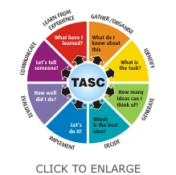  A picture of what my model will look like.

