A photograph of my finished sock character | What did I think of my sock character?    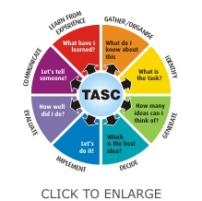  It was great  I would do it differently next time.  Can you explain why?

