What I will need to make a sock character. |   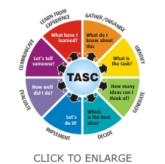  A picture of what my sock character will look like.

