What I will need to enhance my painting. |   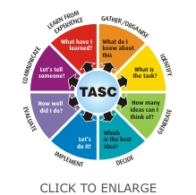  A picture of what my character will look like.  It was great.  I would do it differently next time.
A photograph of my character.

What did I think of my painting?

