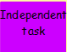
Today is Augustus Gloop's birthday.

He goes to the shop to buy some sweets.
He can choose from:

- Packs of Everlasting Gobstoppers (4 in a pack).
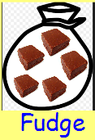

- Packs of Strawberry Flavoured Chocolate-Coated fudge (5 in a pack).

Can you fill in the table with the number of packets of each sweet that Augustus buys?

Packets of Gobstoppers  (4 in a pack) | Packets of Fudge  (5 in a pack) | Total no of sweets
 |  | 4
 |  | 5
 |  | 8
 |  | 9
 |  | 10
 |  | 12
 |  | 14
 |  | 15
 |  | 20
 |  | 20

