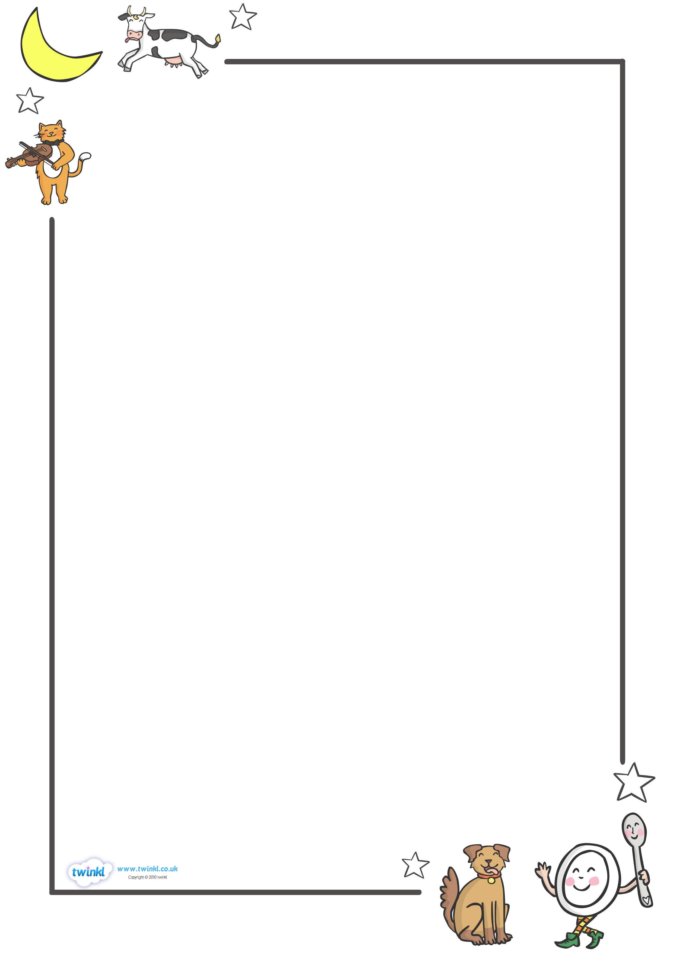
Wc 29.06.20
Walt: Write a letter to your new class teacher to introduce yourself.

TEXT HERE

