WALT – write a report about The Bad Tempered Ladybird Name
A diagram



I can say a sentence I want to write.

I can segment the sounds in words.
I can write some letters to represent the words I want to write.
I can say what the marks I make mean.

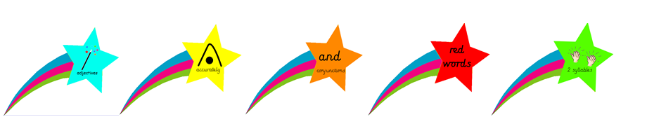

I can say a sentence I want to write.

I can segment the sounds in words.
I can write some letters to represent the words I want to write.
I can say what the marks I make mean.

