WALT - use Fred talk to segment

WILF I can segment orally
I can write a letters in response to a sound
I know that two letters make one sound

   | 
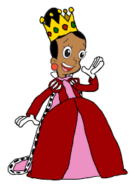 | 

Challenge: can you write a sentence using one of the words now?

