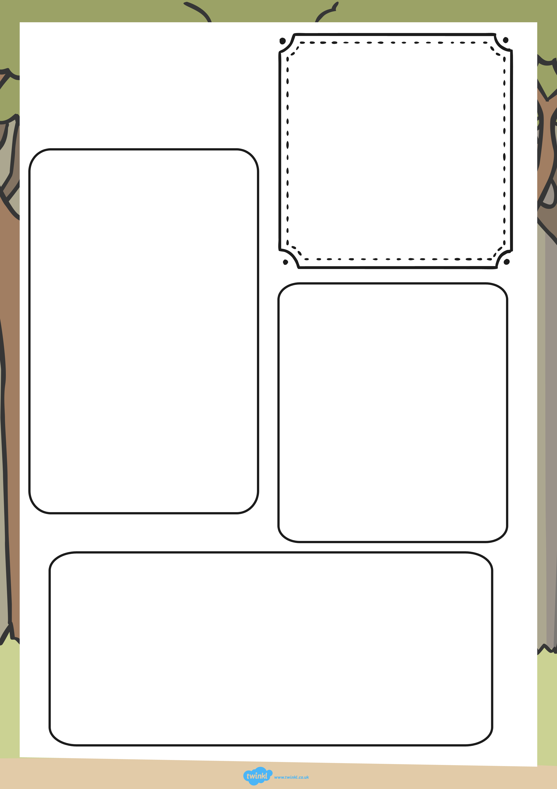
What do they look like?
________________________________________________________________________________________________________________________________________________________________________________________________________________
What do they eat?
________________________________________________________________________________________________________________________________
Where do they live?
__________________________________________________________________________________________________________________________________________________________________________
________________
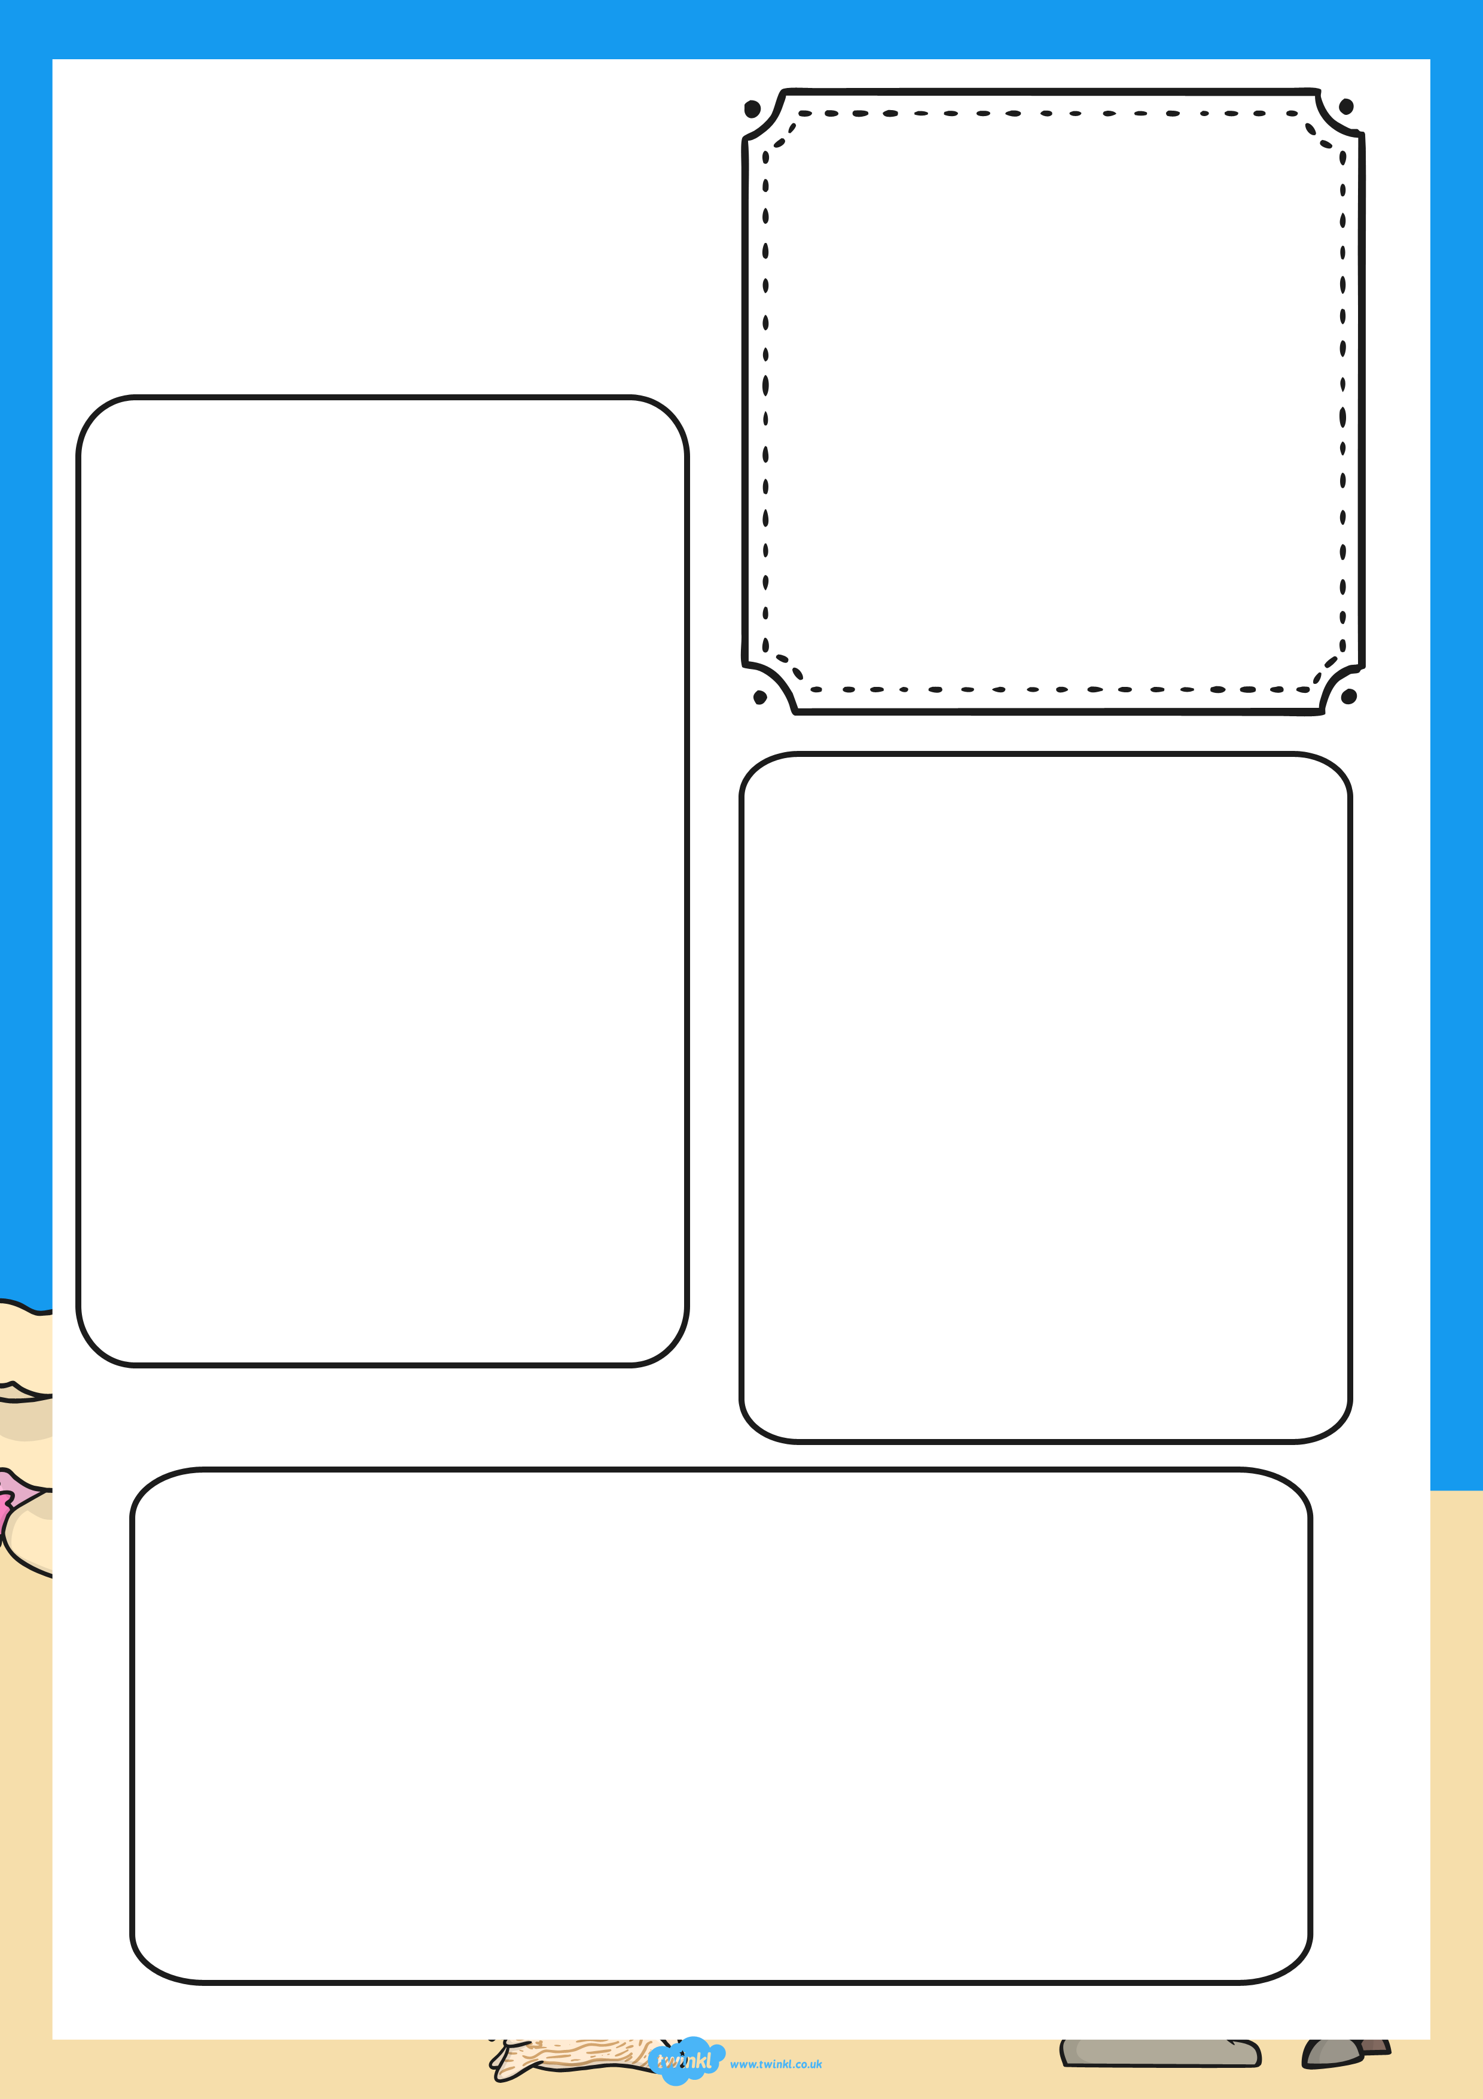
What do they look like?
________________________________________________________________________________________________________________________________________________________________________________________________________________
What do they eat?
________________________________________________________________________________________________________________________________
Where do they live?
__________________________________________________________________________________________________________________________________________________________________________
________________
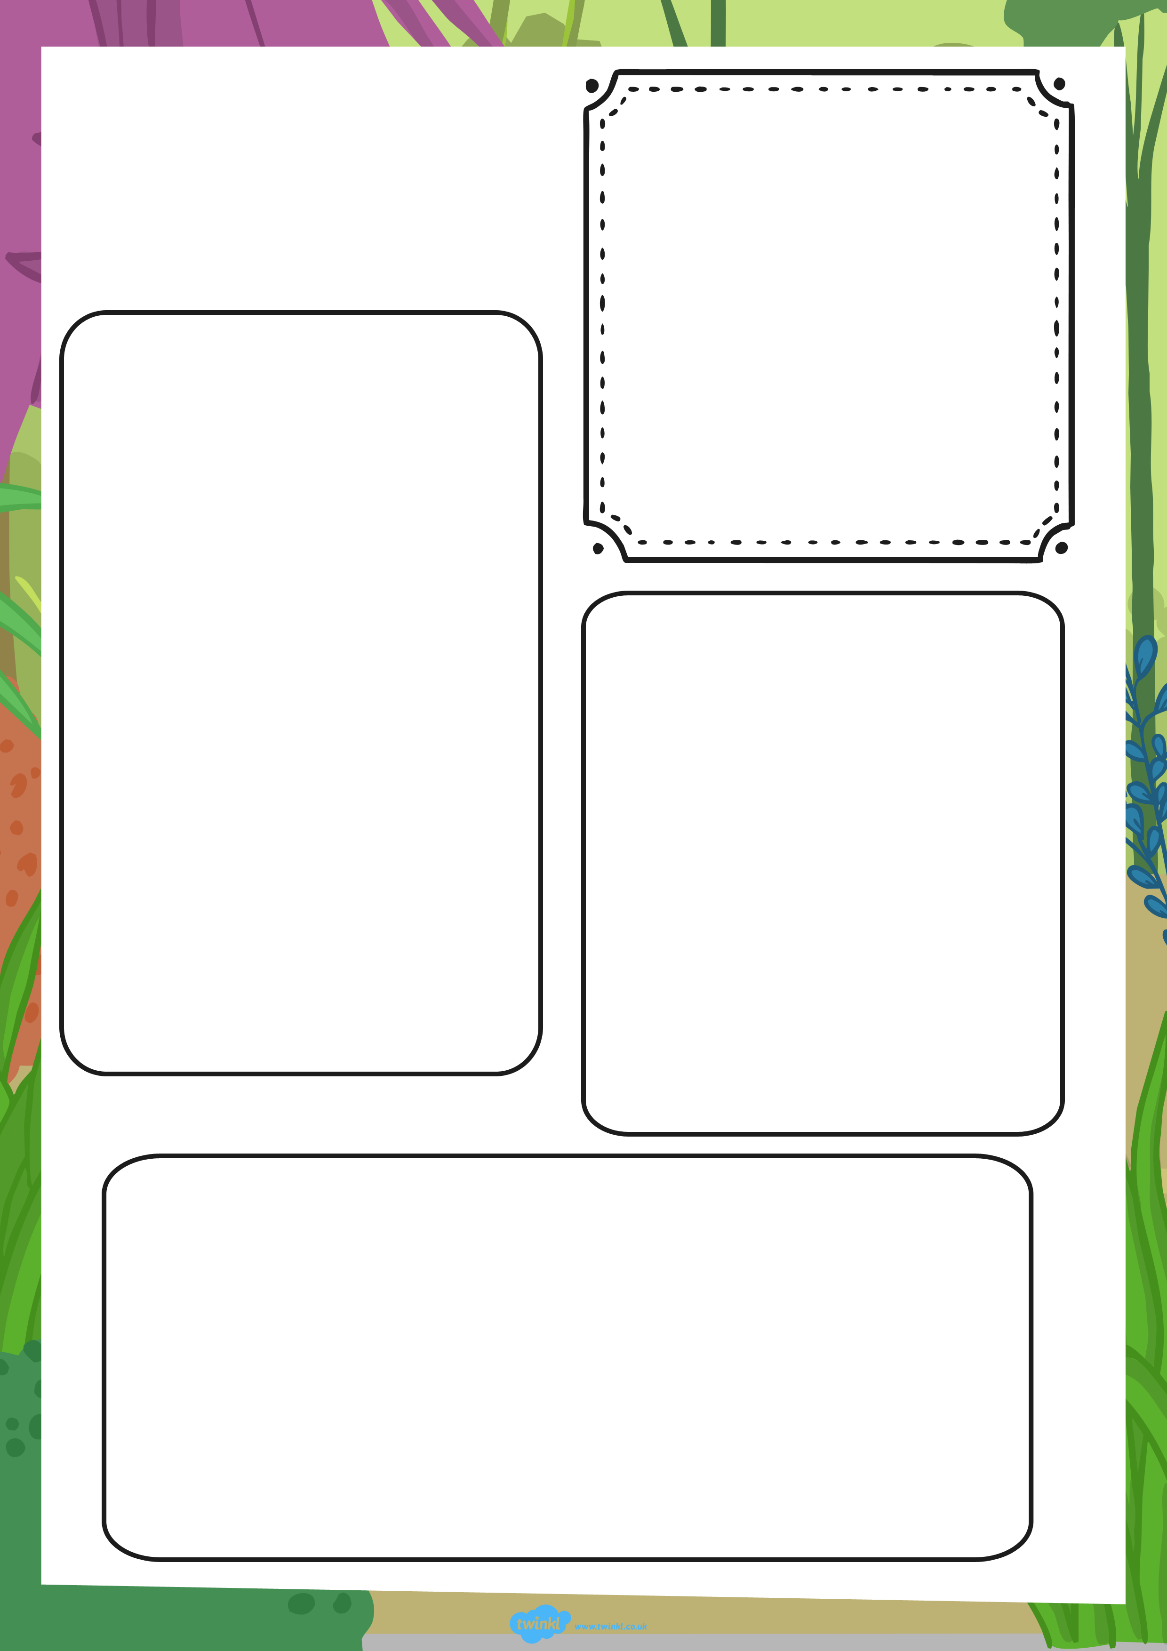
What do they look like?
________________________________________________________________________________________________________________________________________________________________________________________________________________
What do they eat?
________________________________________________________________________________________________________________________________
Where do they live?
__________________________________________________________________________________________________________________________________________________________________________
________________
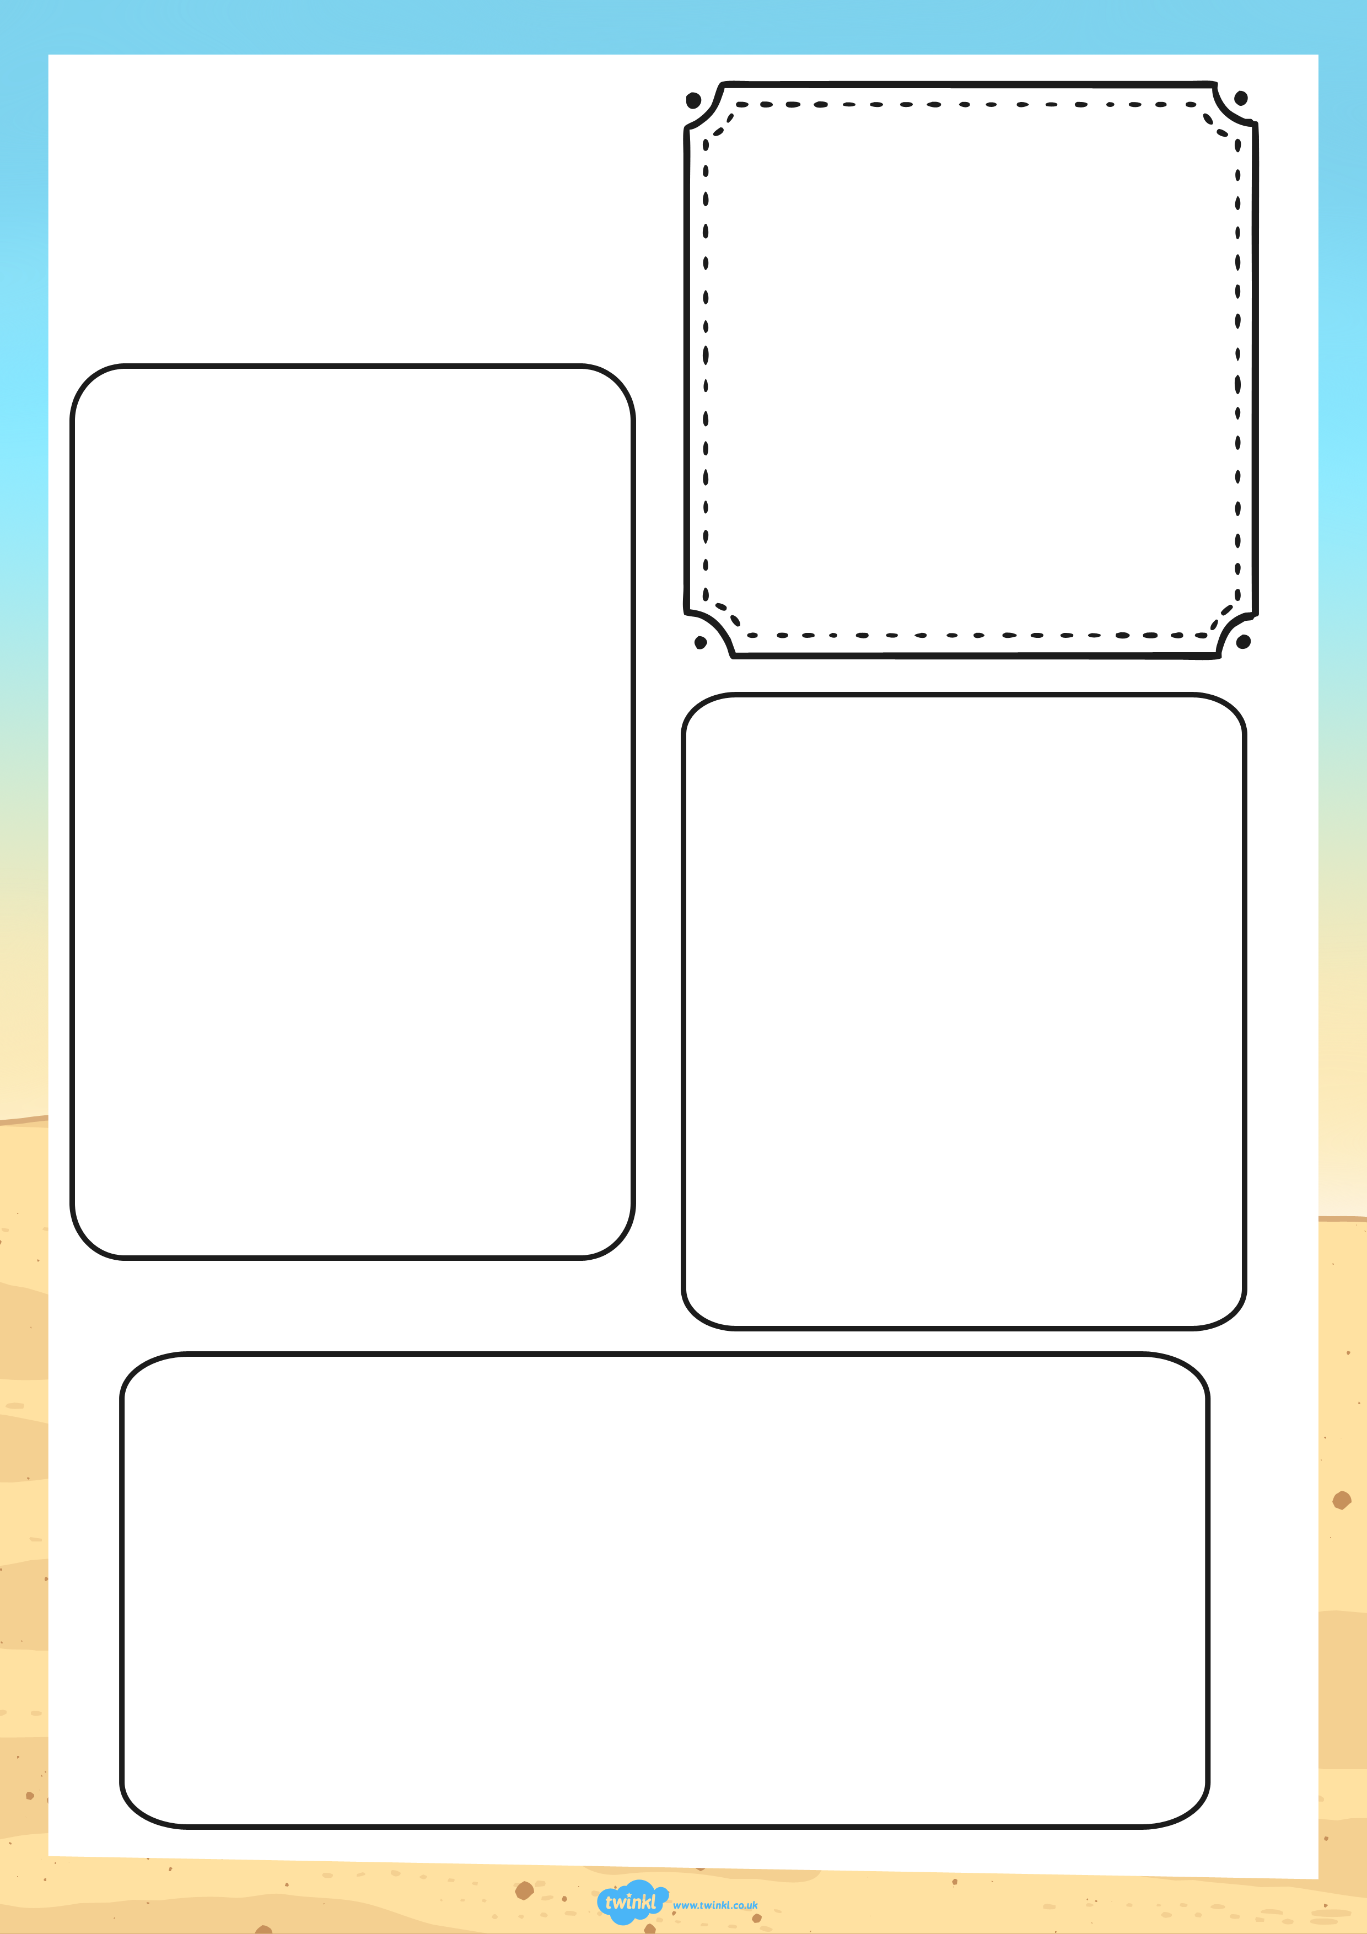
What do they look like?
________________________________________________________________________________________________________________________________________________________________________________________________________________
What do they eat?
________________________________________________________________________________________________________________________________
Where do they live?
__________________________________________________________________________________________________________________________________________________________________________
________________
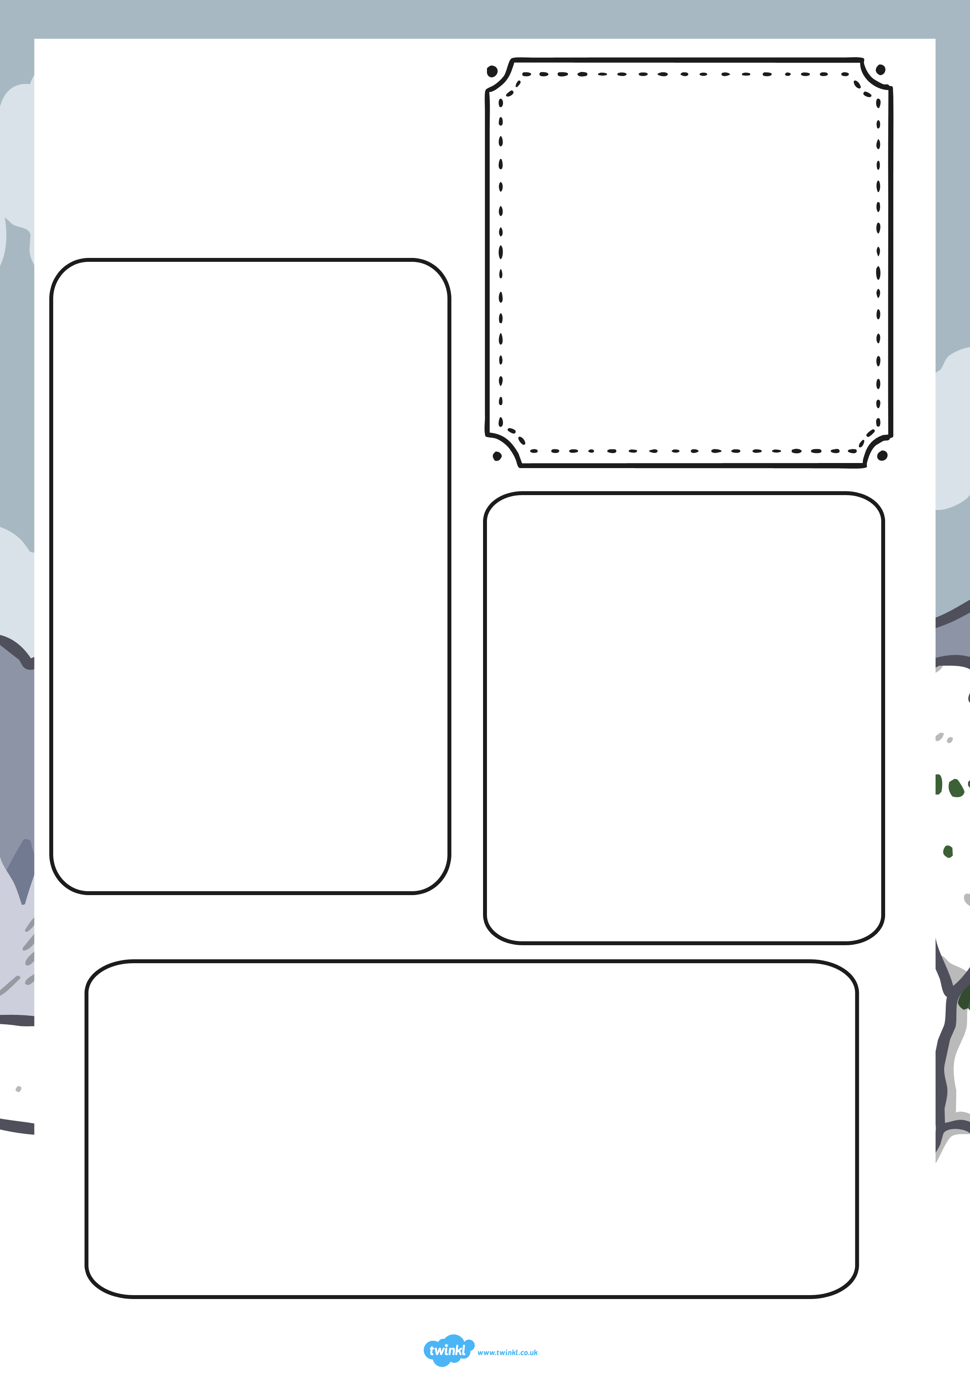
What do they look like?
________________________________________________________________________________________________________________________________________________________________________________________________________________
What do they eat?
________________________________________________________________________________________________________________________________
Where do they live?
__________________________________________________________________________________________________________________________________________________________________________
________________
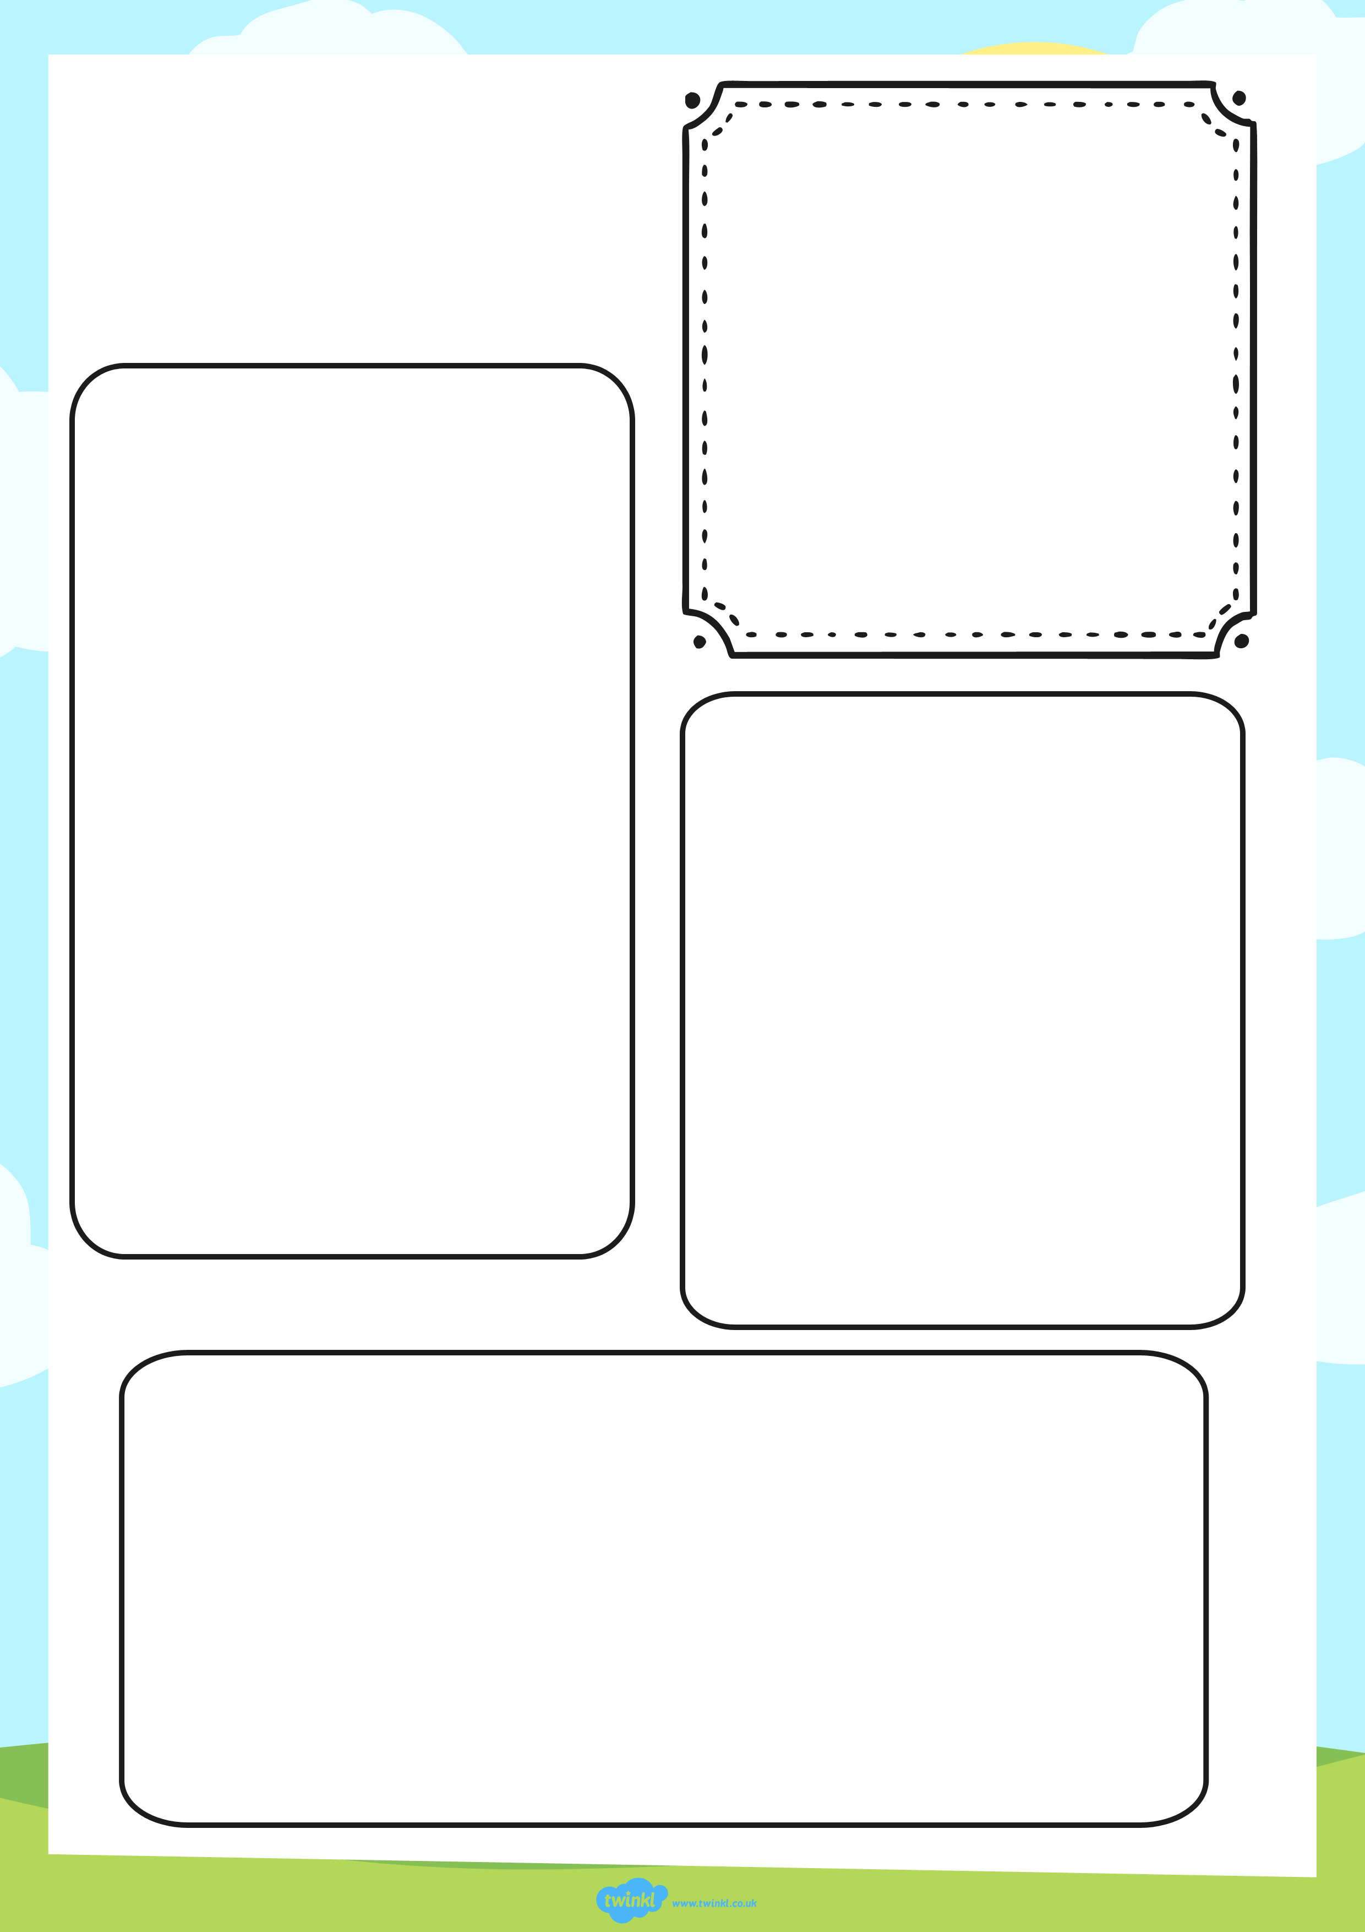
What do they look like?
________________________________________________________________________________________________________________________________________________________________________________________________________________
What do they eat?
________________________________________________________________________________________________________________________________
Where do they live?
__________________________________________________________________________________________________________________________________________________________________________
________________
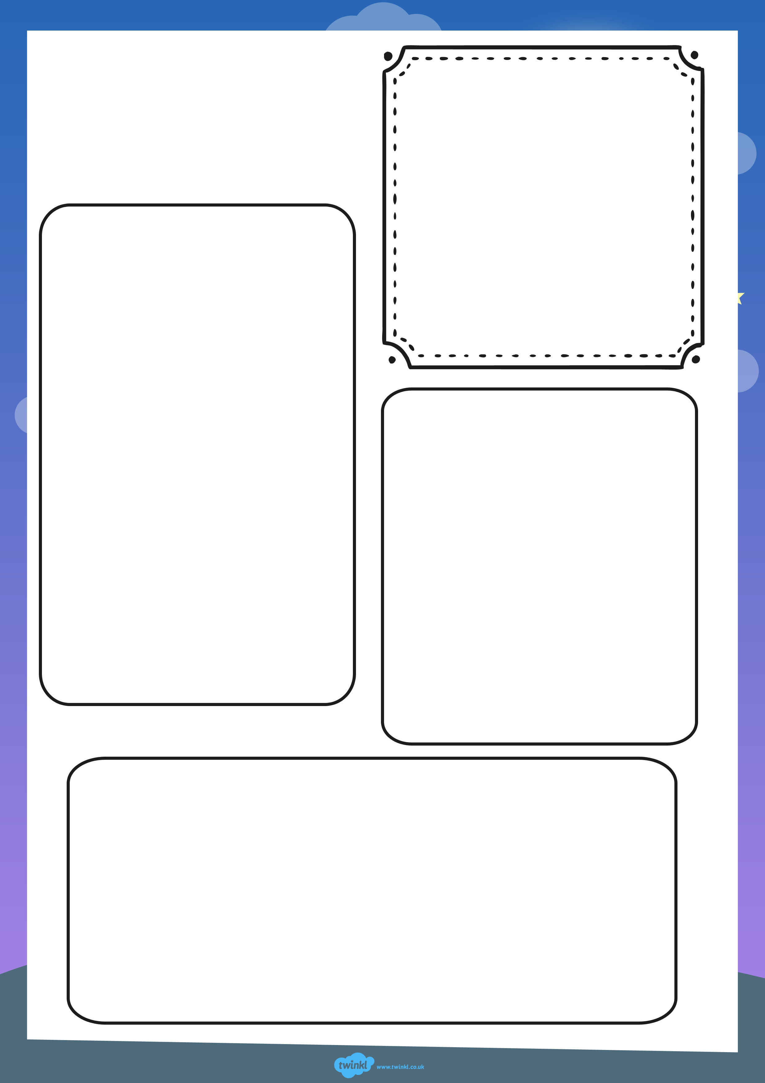
What do they look like?
________________________________________________________________________________________________________________________________________________________________________________________________________________
What do they eat?
________________________________________________________________________________________________________________________________
Where do they live?
__________________________________________________________________________________________________________________________________________________________________________
________________
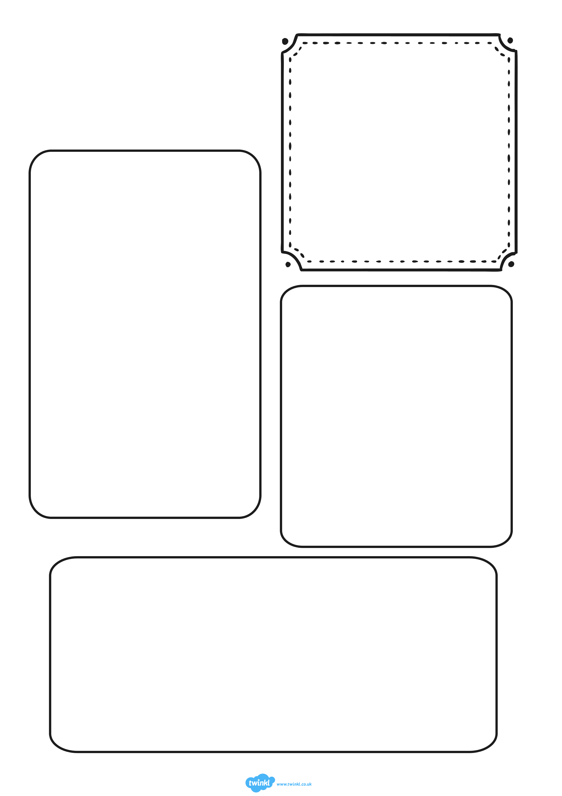
Text
What do they look like?
________________________________________________________________________________________________________________________________________________________________________________________________________________
What do they eat?
________________________________________________________________________________________________________________________________
Where do they live?
__________________________________________________________________________________________________________________________________________________________________________
________________

