Emotions and related behaviour

The Incredible 5-point scale; Kari Dunn Baron & Mitzi Curtis

This scale can be used to help children with an autistic spectrum condition to understand and control their social interactions and responses. It can be used to rate anything from voice to stress levels. The key to using the scale is to involve the child in assigning the ratings to the scale. The scale consists of 5 points, with each point/number representing a different level of e.g. volume or anger. Each number is given a different colour. In this way the scale acts as a visual representation of the child’s feelings or actions.

An example: Stress

The scale may be used for stress levels, where a child perhaps doesn’t understand when they are feeling stressed, or how to deal with this stress. With support, the child can think about and describe how it feels to be (1) calm, (2) slightly anxious, to (5) highly stressed. The child may not associate physical feelings with particular emotions, or understand their own emotions. Therefore, they can be encouraged to think about what they do at each of these stages (e.g. when they are stressed they may start to feel hot, and take off an item of clothing). They can then think about what the best course of action may be for each point (e.g. taking deep breaths or getting a drink of water). At point 5, they will probably need support from an adult. They may want to draw some faces to show how they feel at each point.

This scale can then be used either by the child as a visual prompt of what to do, or to help them describe what they are feeling. Or the scale can be used by the adult to prompt the child as to the correct response to the situation/their feelings. Separate colour cards on a key ring may be used as he child makes associations between the number/colour and what they are feelings, or decided course of action. e.g. showing them an orange 3 may remind them to take some time out, or the child may shout 3 as they leave the classroom as means of explaining that they are stressed and need some time out.

For more information on using the scale contact the team.

Some examples are shown below

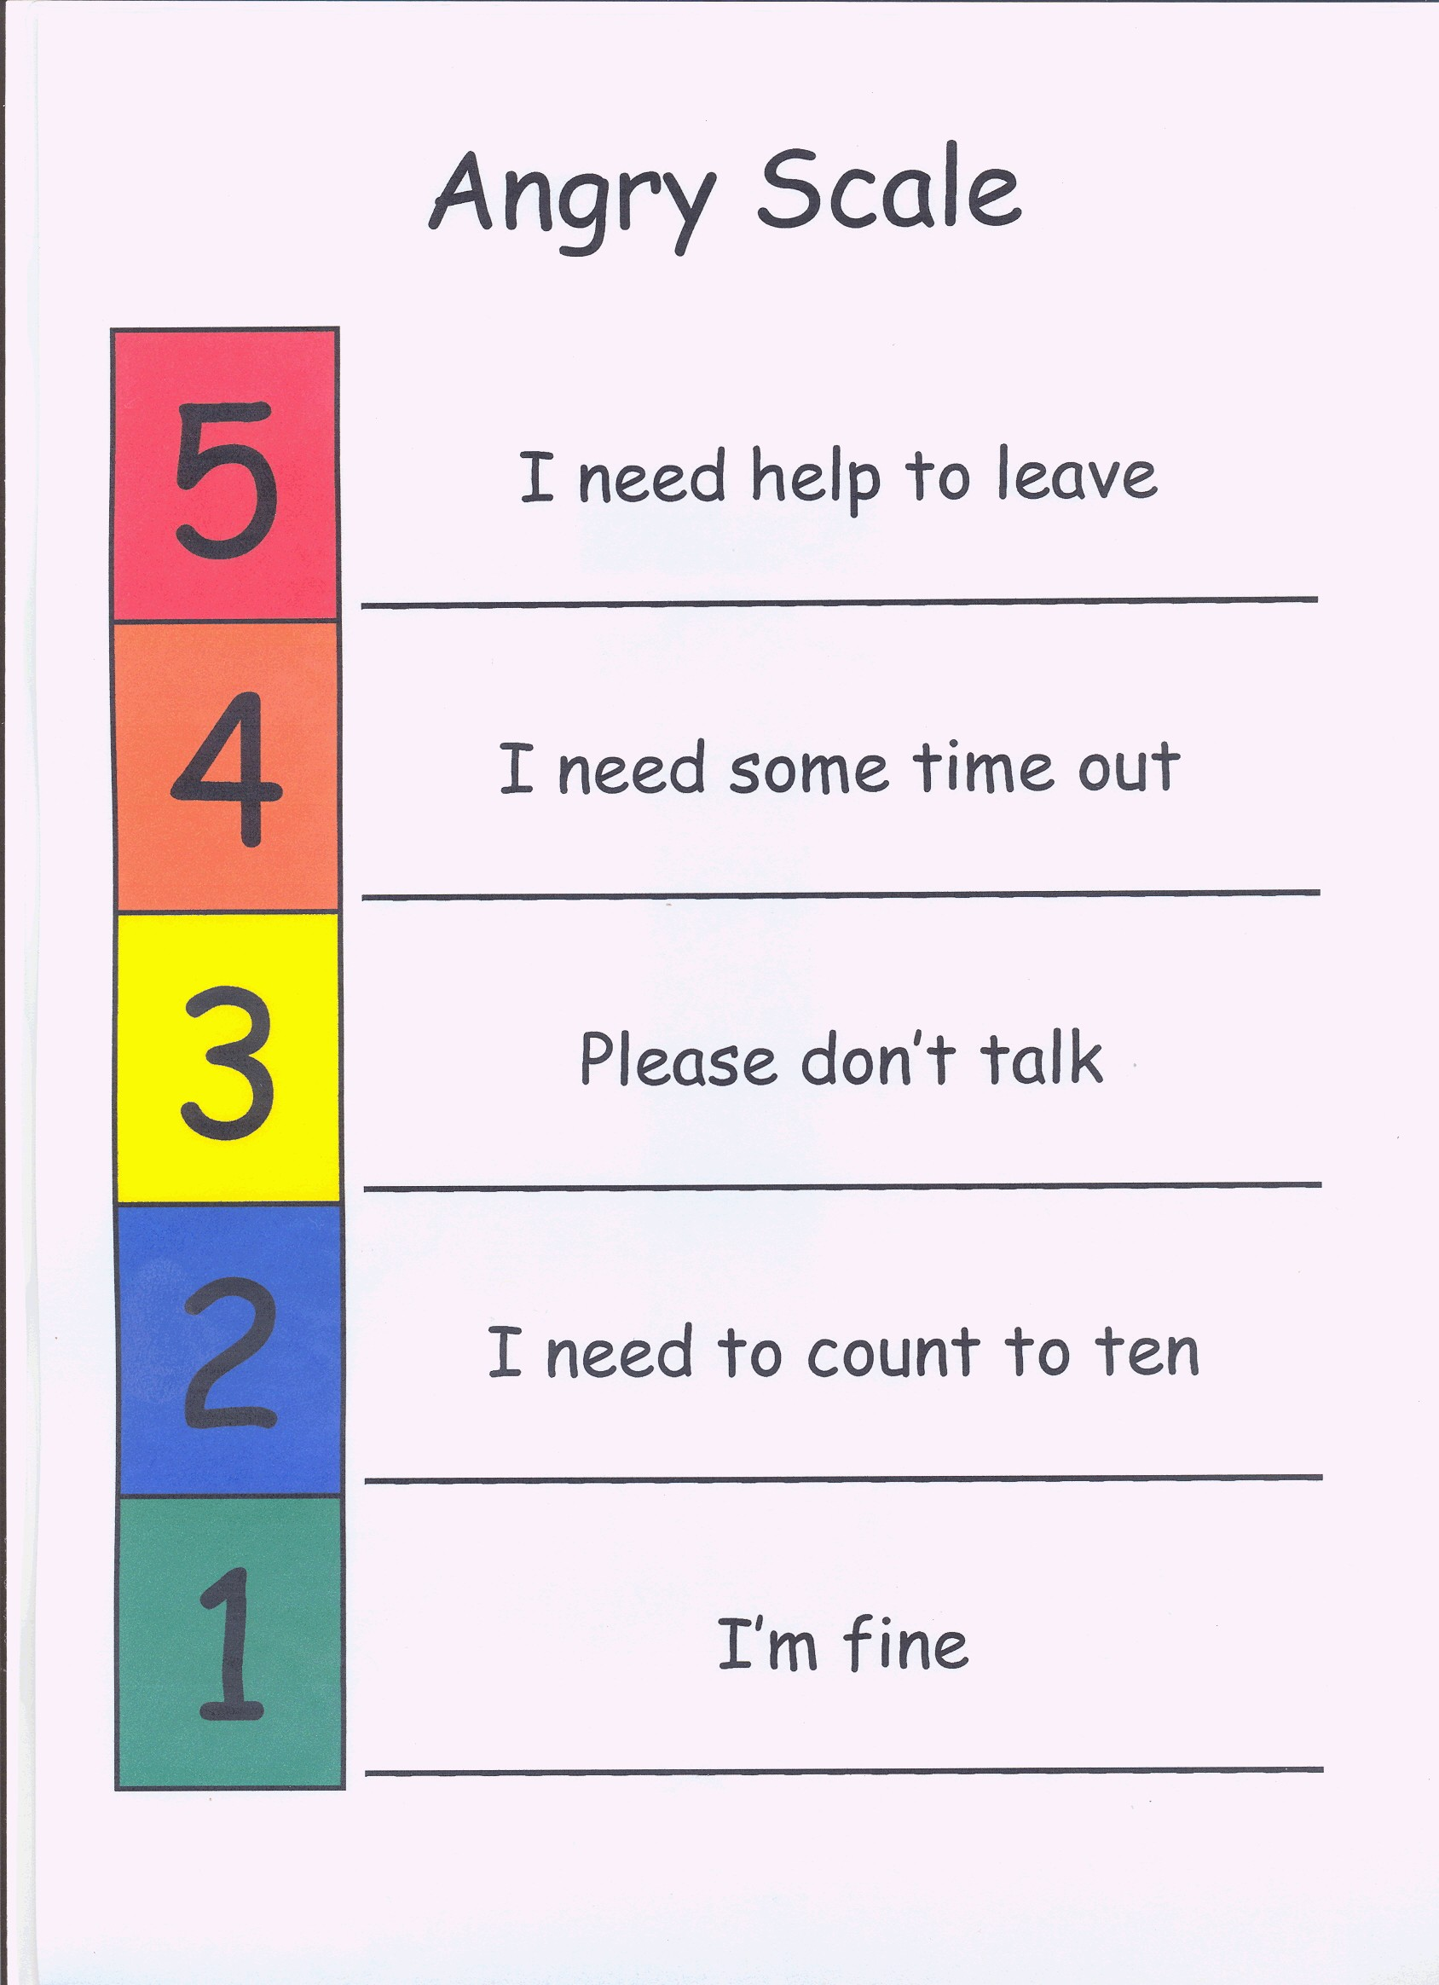
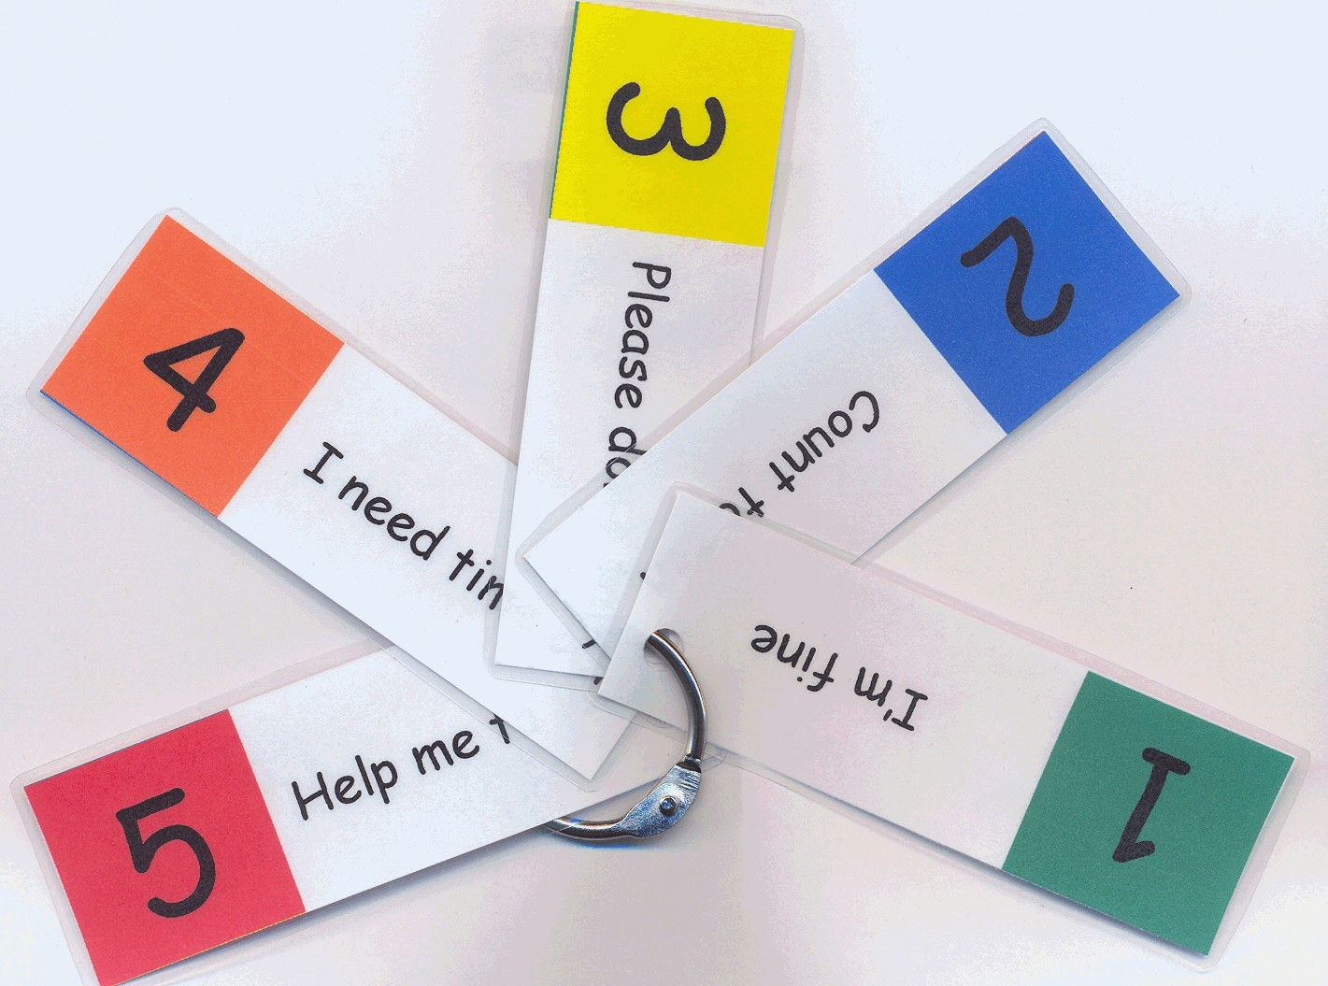
(An example key ring for the child or supporting adult to keep in their pocket. For some children, just having this key ring in their pocket is enough to remind them of what they can do to help themselves calm down – don’t think they don’t need it because they are not constantly looking at it).

The scale can be used for a whole class situation as well as for individuals. See the voice volume example below – teachers can use this as a visual reminder to the whole class of how quietly or loudly they should be speaking. 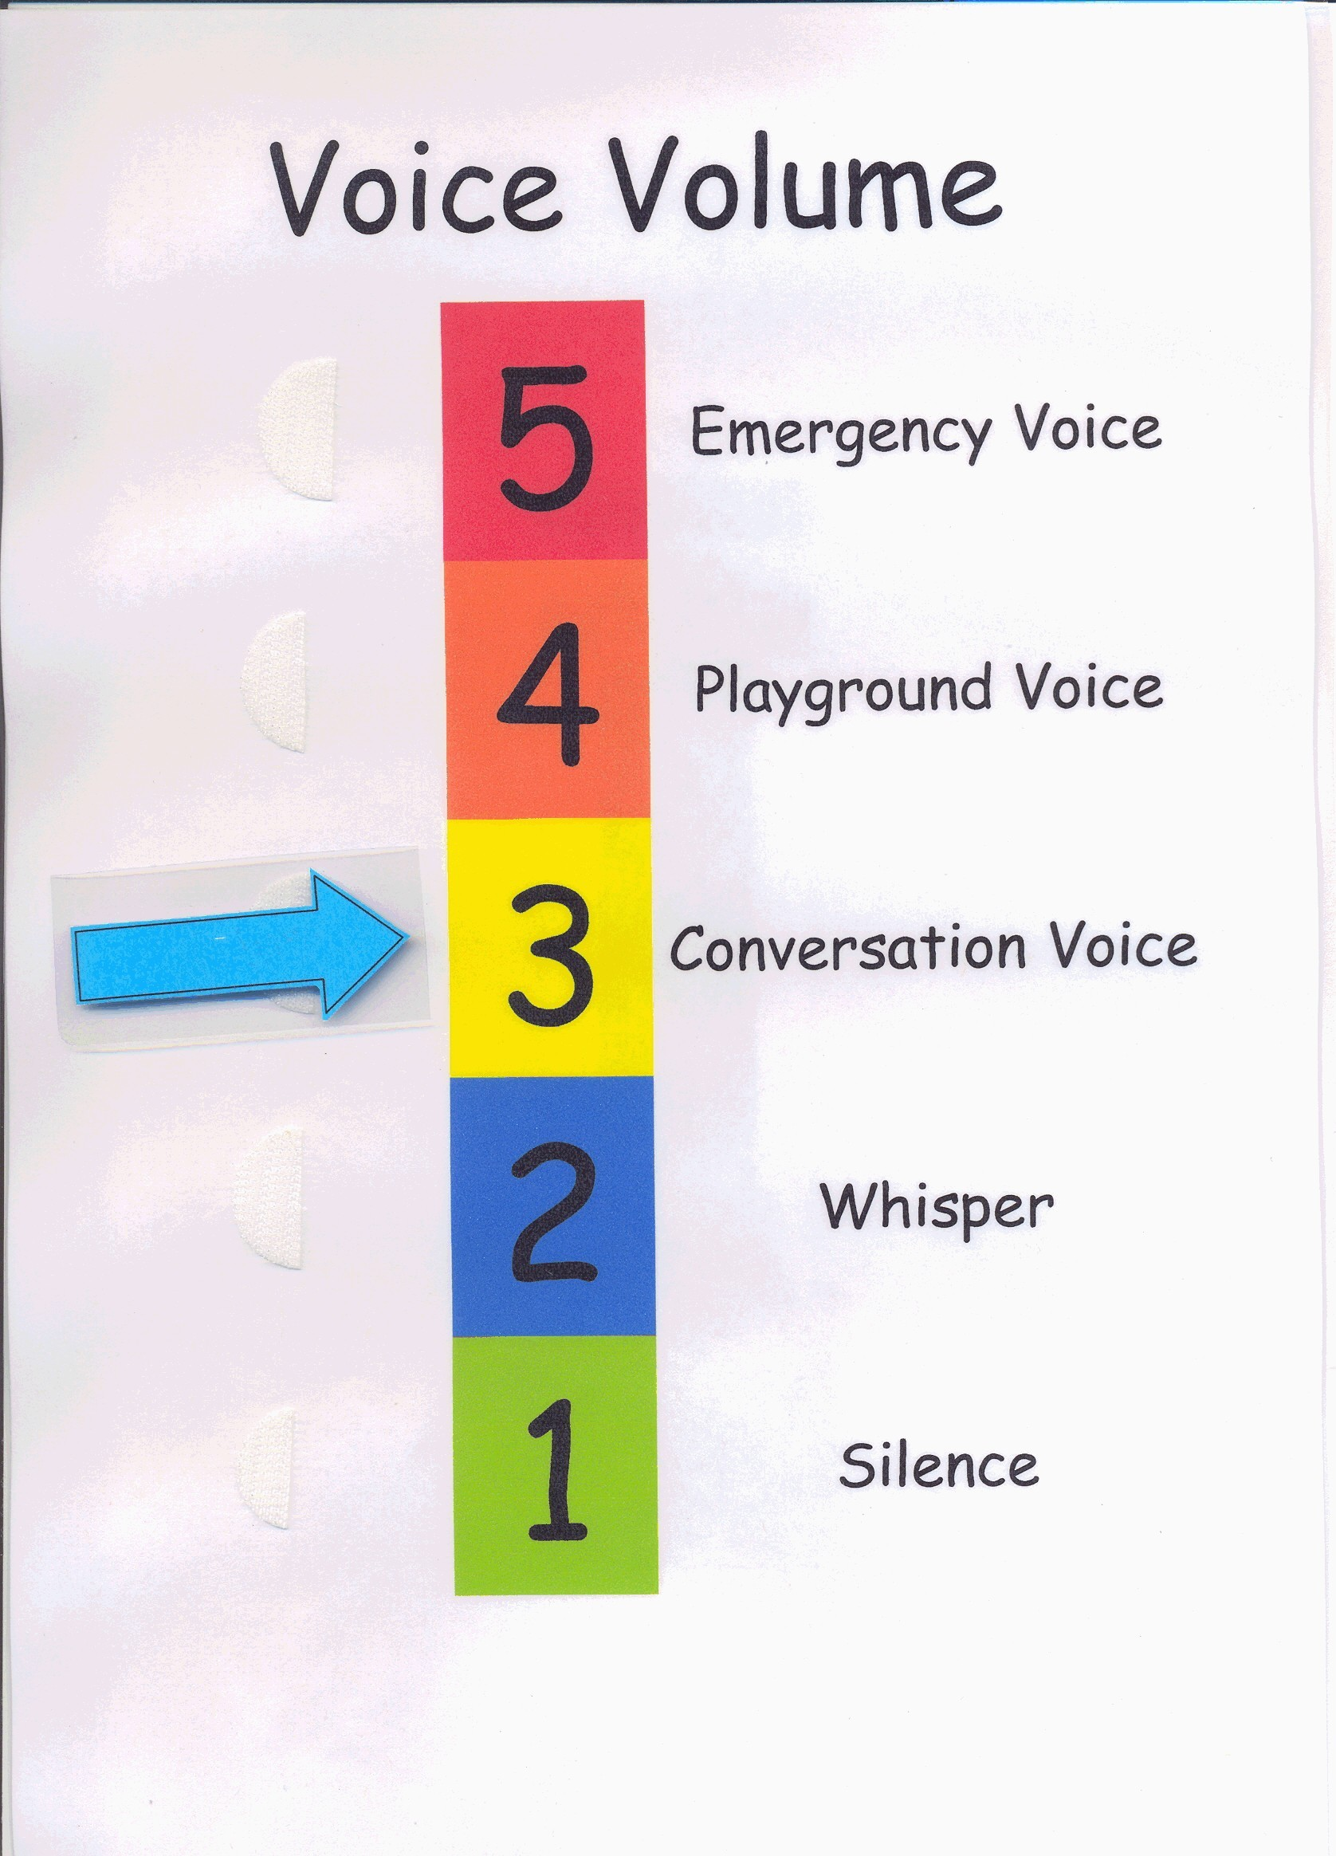

A simpler version of the 5 point scale which also allows a child to express how they are feeling is an emotions barometer. See below. The language used should be the language that the child uses. Knowing how the child is feeling will allow teachers/ teaching assistants to relate or respond to the child appropriately.
