Year 2 RHE Knowledge Organiser
Autumn 2
Theme: Friends
 | Key Knowledge | Key Vocabulary
 | By the end of this unit pupils will…  Know that not all friends are the same and they will understand that it is ok for friends to disagree or like different things. They will be able to say what they might do if they run into problems in a friendship e.g. tell a grown up, use the Stop, Calm Do strategies (see below) or compromise ideas. The children will revisit the term bullying and be able to name different types of bullying, These will include, cyber bullying, physical bullying, verbal bullying and indirect bullying.  Children will learn the word “respect” and understand that they must respect the opinion of others even if it is different to their own.  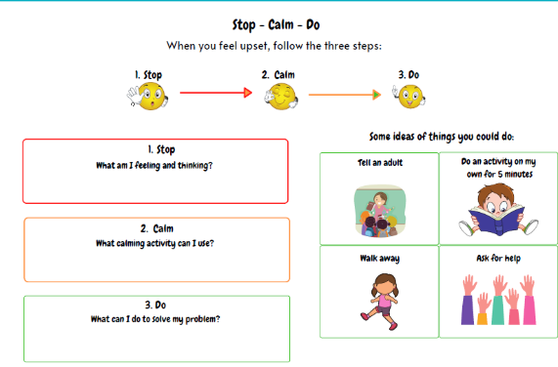  Children will also build on their road safety knowledge and learn to name the different types of crossings on the roads. These include zebra crossings and pedestrian crossings. | Respect Accepting someone for who they are.  Opinion What you think about something  Agree When you think someone else is right  Disagree When you think someone else is wrong  Verbal Expressing yourself using words  Physical Expressing yourself using your body.  Road Safety  Zebra Crossing An area of the road with black and white stripes where the vehicles must stop if someone is waiting to cross.  Pelican crossing A crossing with traffic lights that is operated by people.  Pedestrian Someone on foot.  vehicle A machine with wheels and an engine used for moving goods and people.
 |  | Local Links / Exciting Books/Associated Trips
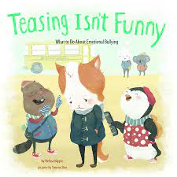
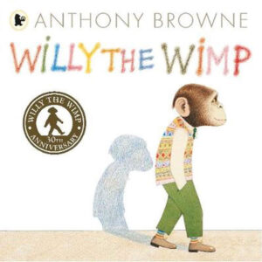
Willy the Wimp by Anthony Browne

Teasing isn’t funny

