Year 2 RHE Knowledge Organiser
Spring 1
Theme: Family, Online Safety
 | Key Knowledge | Key Vocabulary
 | By the end of this unit pupils will…  Family  Know that everybody family looks different. Children be able to identify differences including race, size and religion.  The children will also learn that certain parts of their body are private and that we must ask permission before touching someone. else.  Online Safety  Be able to define “ permission” and say why we need to ask for permission when going online  The children will know that know that most people online are strangers and that some of the things that are posted on line are not true. They will learn the term “fake news”  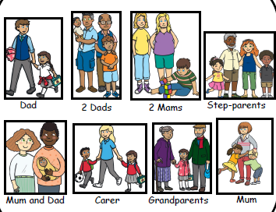 | Family  Gender If someone identifies as a boy or girl  Race A group of people who may have features in common. This could include skin tone or hair type.  Age How many years you have lived since birth  Private The things that are just for us.  Trust The people that we rely on to help us.  Online Safety  Permission To be allowed to do something  Fake Something that is incorrect or untrue
 |  | Local Links / Exciting Books/Associated Trips
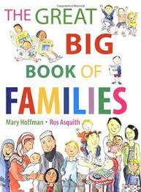
The Big Book Of Families
By Mary Hoffman

