Year 2 RHE Knowledge Organiser
Spring 2
Theme: Feelings
 | Key Knowledge | Key Vocabulary
 | By the end of this unit pupils will…  Understand that everyone is different and learn the term unique.  They will learn that everyone deserves to be treated with kindness and respect  Be able to link different feelings to different situations and be able to say how they feel when they sleep, eat or exercise. The children will be able to say what makes them feel happy, sad, angry and worried.  The children will also be able to recognise the scale of the conflict and identify whether something has caused a big conflict or a small conflict. The children will discuss real life scenarios and be able to say what strategies they could use to deal with the conflict.  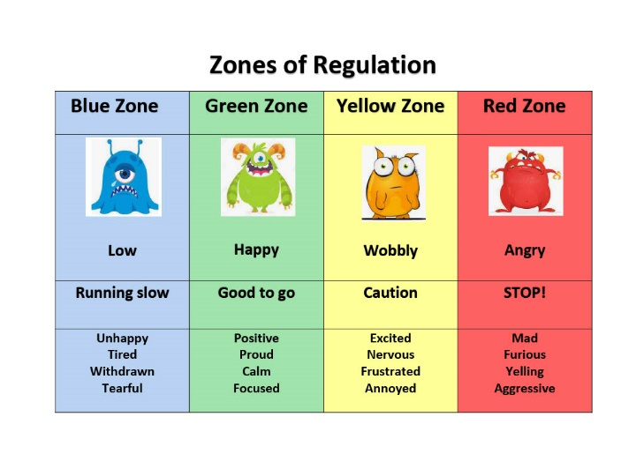  The children regularly use our zones of regulation check-in to say how they are feeling. | Feelings  Unique Being the only one  Pride Feeling proud of who you are  Conflict A struggle from having different opinions or needs  Conflict A struggle from having different opinions or needs  Compromise Where both sides agree to meet in the middle  Emotions The feelings you have.
 |  | Local Links / Exciting Books/Associated Trips

Watch the Pixar Film Inside Out

