Year 2 RHE Knowledge Organiser
Summer 2
Theme: Growing Up
 | Key Knowledge | Key Vocabulary
 | By the end of this unit pupils will…  Be able to say what a habit is and list good and bad habits. These might include exercise washing and sleeping routines as well as habits that the children want to break like thumb sucking. The children will understand that these will change as they grow.  The children will also learn to use the scientific names for different external body parts. These will also include male and female external body parts.  The children will know that parts of your body are private and be able to explain what “private” means. The children will learn that different traits such as braveness or kindness are not linked to any particular sex.  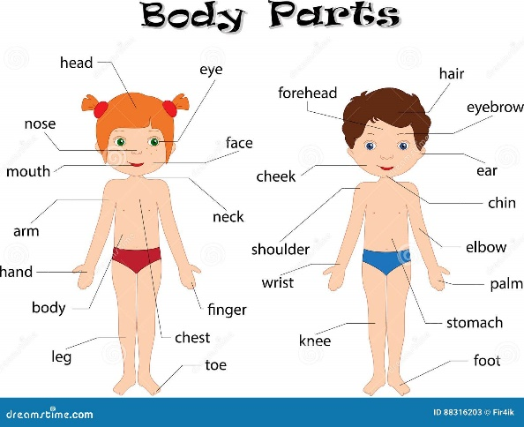 | Habit A usual way of behaving  Boy A child who is male  Girl A child that is female.  Negative Something that could be harmful  Private Something that you don’t want to share.  Trust Having someone who is there for you
 |  | Local Links / Exciting Books/Associated Trips
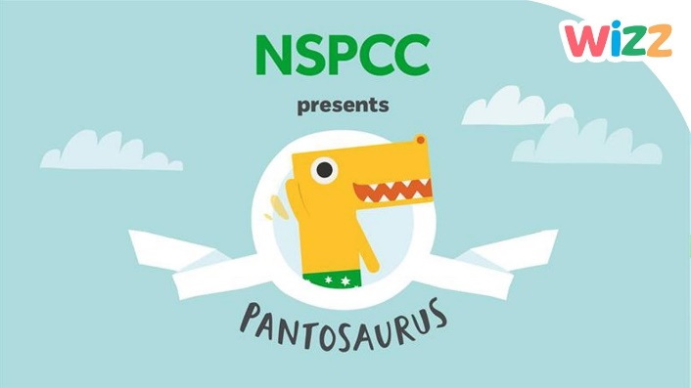

Listen to the “Pant Song” on
the NSPCC website

