Year 2 RHE Knowledge Organiser
Summer 1
Theme: Staying Healthy/Road Safety
 | Key Knowledge | Key Vocabulary
 | By the end of this unit pupils will…  Children will be able to name the 5 different food groups: carbohydrate, fats, fruit and vegetables, dairy and protein and give examples of food that fall in to each group.  Children will be able to discuss the impact physical activity can have on their body and also explain the benefits of relaxation time.  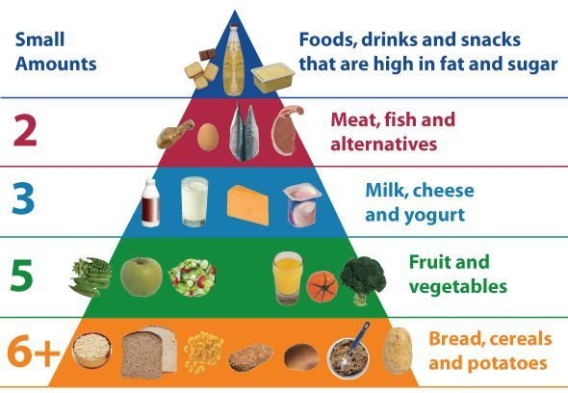  The children will be able to recognise dangers they may experience inside and outside the home including: medicines, electricity, fire, and water. They will also know that they must tell an adult or ring 999 in an emergency. | Staying Healthy  Heart Organ that pumps blood through the body  Energy The ability to do work  Relaxation When your body and mind are free from stress  Diet The things that you eat and drink  Healthy Making choices that look after your body and mind.  Safety  Danger Being at risk of getting hurt  Emergency A situation where help is needed straight away  Help To give assistance or support  adult Someone over 18 years of age.
 |  | Local Links / Exciting Books/Associated Trips
Share the Green Cross Code as home and put it in to practise by taking a walk around your local area together. Practise using different types of crossings
