Year 1 RHE Knowledge Organiser
Summer 1
Theme: Staying Healthy
 | Key Knowledge | Key Vocabulary
 | By the end of this unit pupils will…  Children will learn to understand how their bodies can be different to others. Children will understand that not everyone looks the same and that not everyone has a body that can do the same things.  Children will understand how they can keep their body healthy by exercising, brushing their teeth, eating healthy diet, handwashing and sleeping well. They will learn in detail what make a good handwashing and oral hygiene routine.  Children will also understand what germs are and how they can stop germs from spreading by practising good hand hygiene.  The children will also learn about the dangers that can be caused by the sun and learn how to protect their bodies.  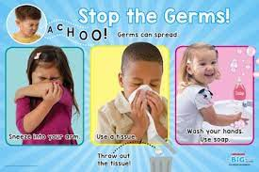 | Body Everything that makes up your physical self including skin, hair, muscles and organs  Germ A microorganism that can cause an infection and make you sick  Ability Doing something as well as you can  Disability A condition of the body or mind that makes it more difficult for someone to do something.  Spread To expand over a larger area.  Healthy To not be sick.
 |  | Local Links / Exciting Books/Associated Trips
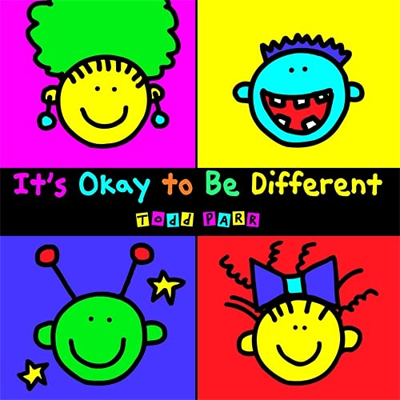

Its ok to be different By Todd Parr

