Year 1 RHE Knowledge Organiser
Spring 2
Theme: Feelings
 | Key Knowledge | Key Vocabulary
 | By the end of this unit pupils will…  Be able to name a range of different emotions including angry, excited, scared, happy, nervous and calm. They will also be able to say what makes them feel this way.  They will begin to understand that big emotions come from their down stairs brain and say what calming down tricks they can use to return to their upstairs brain.  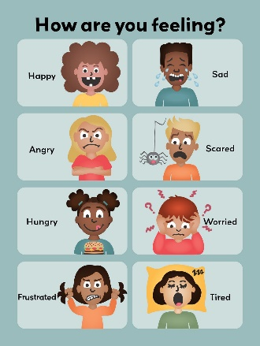  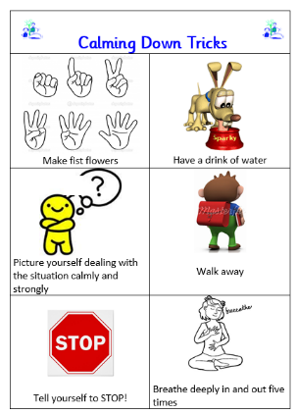  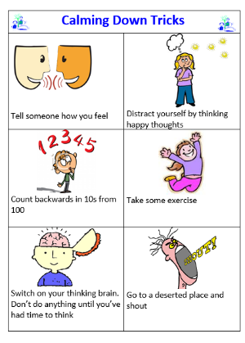 | Angry Being very cross.  Excited Feeling very happy and enthusiastic  Scared Feeling frightened  Happy Feeling good  Nervous Feeling worried and being afraid of what might happen  Calm Feeling peaceful and quiet
 |  | Local Links / Exciting Books/Associated Trips
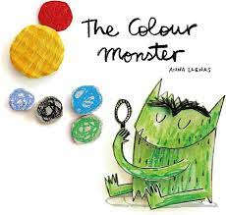

The Colour Monster By Anna Lenus

Start to recognise different emotions that
You can see around you.

Practise using calming down tricks at home.

