Year 1 RHE Knowledge Organiser
Spring 1
Theme: Family, Fair trade
 | Key Knowledge | Key Vocabulary
 | Family  By the end of this unit pupils will…  Be able to say what makes a happy family The children will also understand that families are not all the same and say how a family can vary. The children will also learn that everyone in a family has responsibilities e.g. to go to school or work.  The children will identify the changes that can take place in a family over time such as moving, birth and death.  Online safety  By the end of this unit pupils will…  Understand that screen time means time spend looking at a television, computer, phone or tablet. They will learn that too much screen time can affect the way they feel. They will learn that everyone needs to balance the amount of time spent online and offline. The children learn what their personal information is and way this must be kept private online.   | Family  Family A group of people who are related to each other  Change To make something different  Different Something that is not the same  Same Something equal  Responsibility Being dependable and making good choices.  Online safety  Screen looking at a television, phone or tablet  Online Being connected to the internet  offline Not connected to the internet.  Private Something that is just for you and not to be shared.  Personal information Information that can tell you who a person is. This could be their name, address or birthday
 |  | Local Links / Exciting Books/Associated Trips
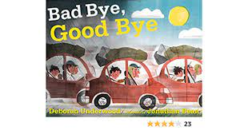

Bad Bye Good Bye by Deborah
Underwood and Jonathon Beek

Can you spot any Fairtrade Logos in the Supermarket?

