Year 1 RHE Knowledge Organiser
Summer 2
Theme: Growing Up/ Transition
 | Key Knowledge | Key Vocabulary
 | By the end of this unit pupils will…  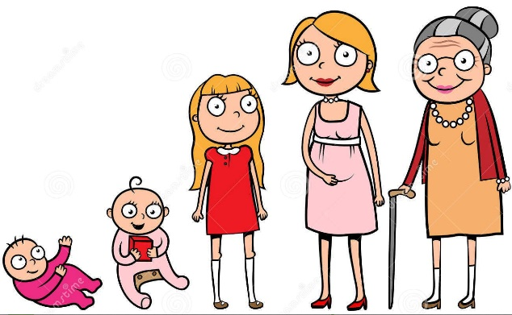  Be able to name the 5 different life stages: Baby, Toddler, Teenager, Adult, and Elderly. They will also be able to identify some of the natural changes that take place in each stage: walking, losing teeth etc.  Children will also be able to name the three types of changes and discuss how change makes them feel.  Three Types of Change:  Planned, natural and unexpected.  This could be changing class, growing your hair or death. | Change To become different  Natural Everything not made by people  Planned Something that’s organised in advance  Transition Moving from one thing to another.  Unexpected Something surprising  Stages Of Life Changes as you grow
 |  | Local Links / Exciting Books/Associated Trips
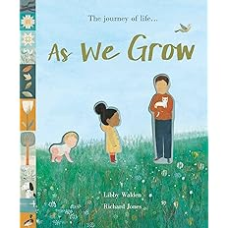

As We Grow – By Libby Waldon
Look at photos together and identify changes
over time.

