Year 1 RHE Knowledge Organiser
Autumn 2
Theme: Friends, Road Safety
 | Key Knowledge | Key Vocabulary
 | Friends  By the end of this unit pupils will…  Learn what a friend is and be able to list the qualities that make a good friend. They will also understand that friends do not always have to agree with each other.  Learn to identify the difference between a close friend and a stranger.  They will learn who they should trust and go to if they need help and also say what they would do if they were approached by a stranger.  The children will be able to say what bullying is and what they would do if they were in a bullying situation.  Road Safety  By the end of this unit pupils will…  Learn to identify dangers on the roads and know to cross a road safely. The children will understand what the Green cross code is and say how it helps them to stay safe.  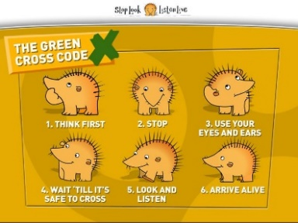 | Friend People that you can have fun with.  Stranger Anyone you don’t know well.  Include To be part of something  Exclude To be left out  Bullying Behaviour that hurts someone else that is done several times on purpose.  Danger Something that might injure or hurt someone.  Safe Not in danger  Road A place for vehicles to travel.  Look Use your eyes to see  Listen Use your ears to listen.
 |  | Exciting Books and ways to support at home
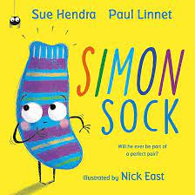
Simon Sock By Sue Hendra
Practise using the Green Cross code on walks in your local area

