

Infant School
Headteacher: Mrs Cathy Rowland
Deputy Head teacher:
Mrs Vicky Harrison
Pingle Road
Sheffield
S7 2LN

Tel: 0114 2368099
Fax: 0114 2368014
E-mail: enquiries@dobcroft-inf.sheffield.sch.uk

20th October 2017

Dear Parents,
As you are aware, a lack of school funding is proving to be a significant challenge for us and will continue to be for some considerable time. Whilst we raise funds through various events during the school year, there is a very simple way all parents can generate money for the school when you shop online.

The Give as you Live site is a free and easy way to raise money for your school, just by shopping online. Once you've signed up, you can browse the website for the store you want to shop with. Dobcroft Infants is already set up on the website and you can complete your online shopping as normal in the knowledge that you are actively raising funds for your school at no extra cost.

It is free and easy to get started and instructions on how to do this have been attached.

Please help your school by shopping online!

Thank you for your support.

Cathy Rowland
Head teacher

Raise free funds for charity | Give as you Live
https://www.giveasyoulive.com
Give as you Live is a free and easy way to raise money for your favourite charity, just by shopping online.
Once you've signed up, you can browse our website for the store you want to shop with. Click 'shop now' to go to their website, then continue to shop as normal.

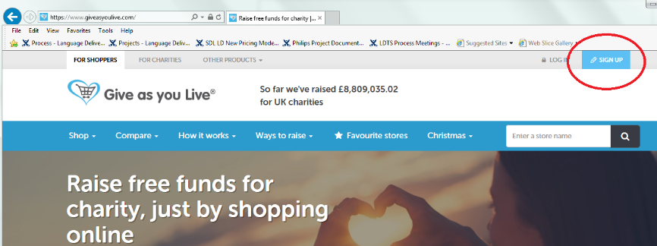

Enter Dobcroft in the ‘Choose a charity to support field. Then click on the school name link under search results
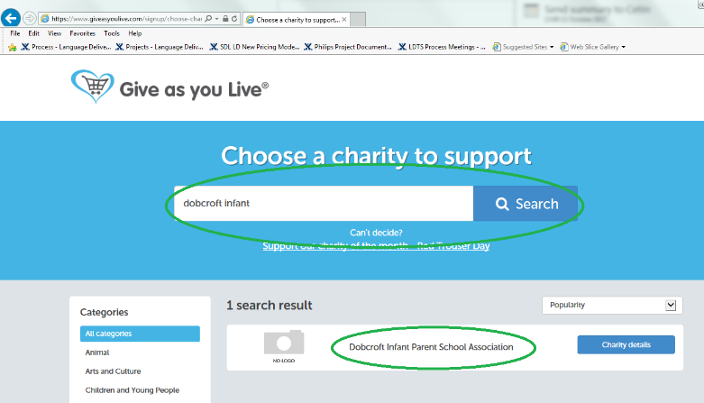
Click Support this charity
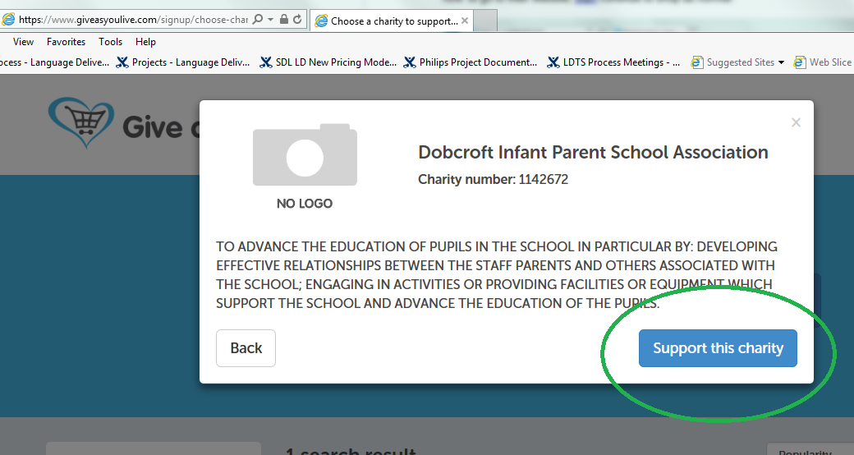
Enter your details in the form ad click create account
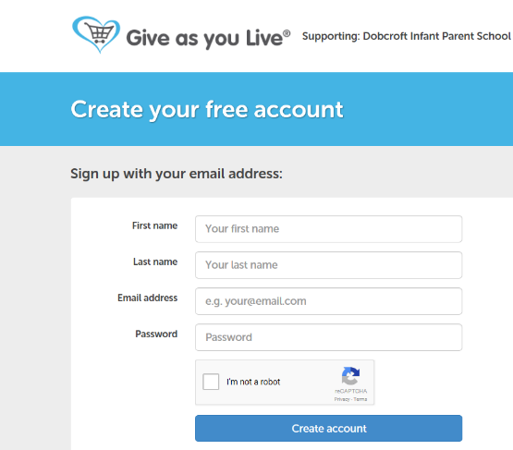

You can choose to select retailers or skip the step.
This will take you to a how does it work page when you can find loads of information about how the service works.
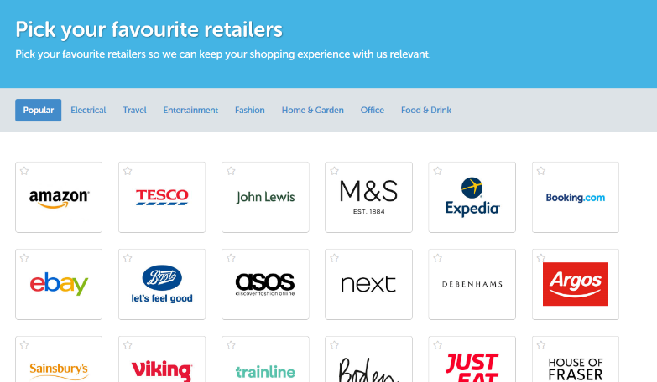

You can browse to the site each time you shop and then search for the store from which you want to shop. You can choose tablet/smartphone or laptop/pc options to install the app or a page bookmark on your bookmarks bar icon for speedier access.
You can have both options set up on one account so you can shop on whichever device you are using at the time.
Tablet/smartphone requires installation of the app. Click visit install page
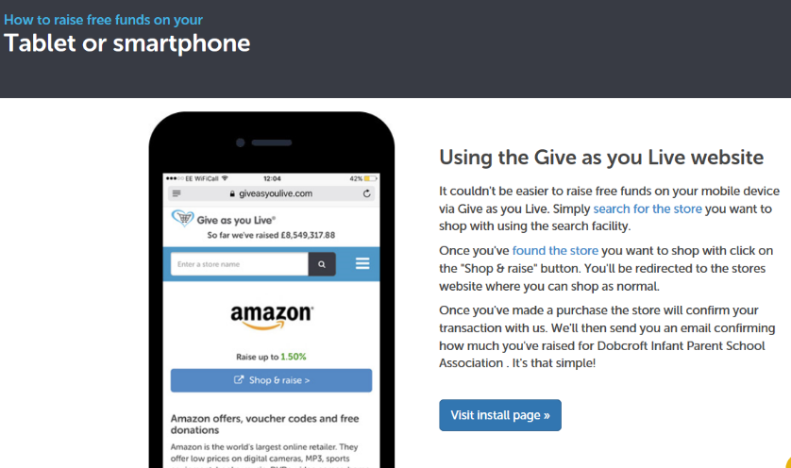

You can even install a donation reminder, which will prompt you when shopping to remember to buy through give as you live to raise funds.

You can raise money when booking holidays as well on utility insurance and other costly items. This is a great way ti raise significant amounts of money at no cost to yourself.
Even Amazon donates 1.50% for everything you spend!!
With Christmas around the corner this really is time to sign up to make sure all your online purchases are going towards making free money for our school.

