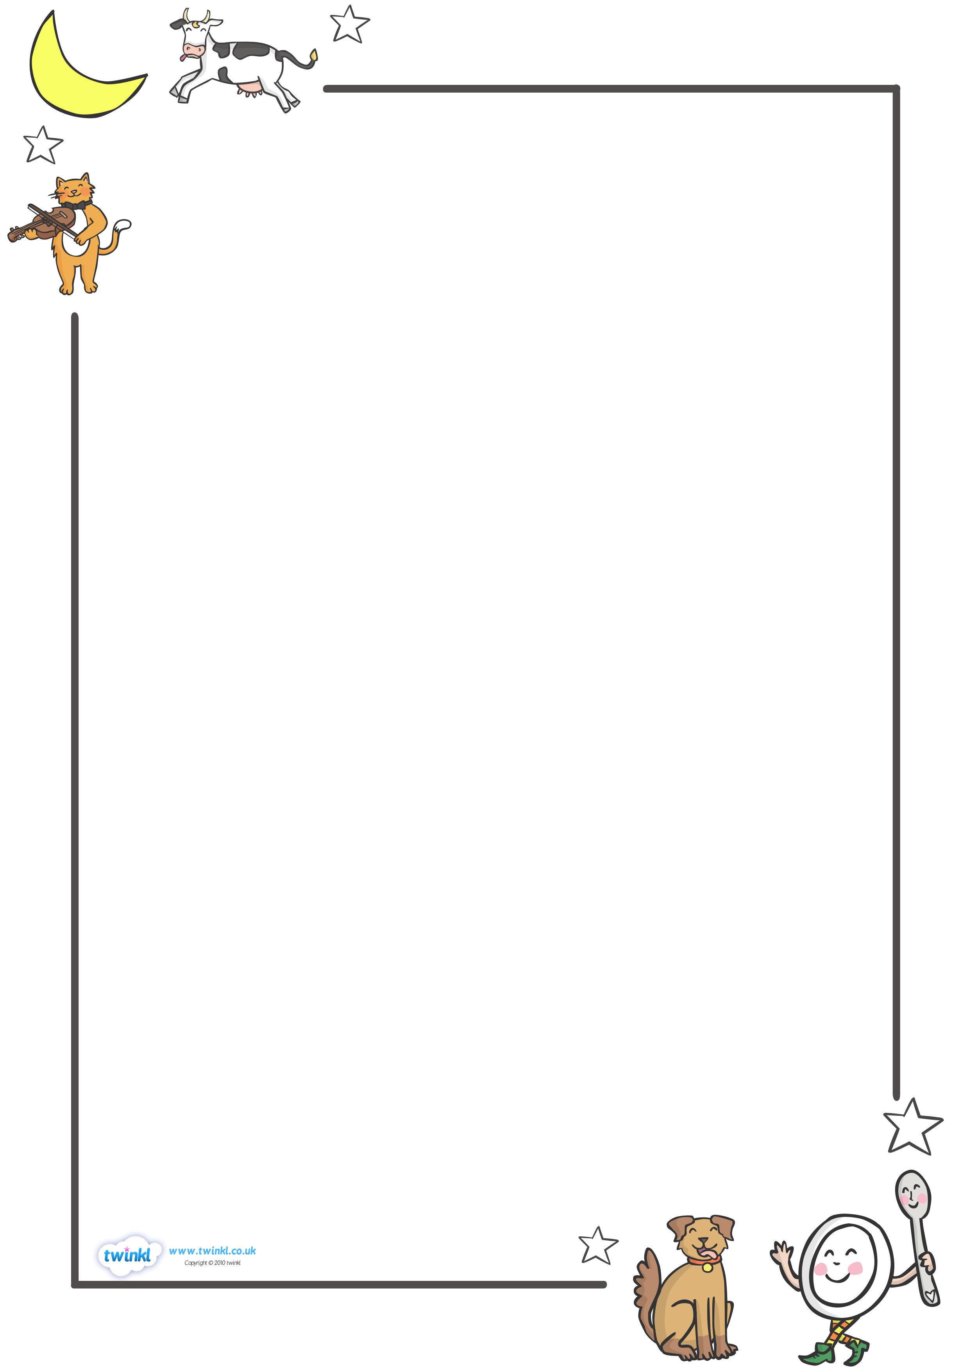
wb 5.07.21
Walt: tell a child who is starting school what the best thing about being in Foundation is.



TEXT HERE

