WALT –count on or back using a number line wc 21.6.21
WILF I can put the larger number first.
I can tell you which operation sign I have selected
I can jump on or back the correct number of jumps
I can record the answer.
Name

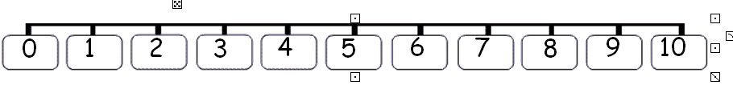
WALT add using a number line wc 19.3.18
WILF I can find the largest number on the number line
I can jump on the correct number of jumps
I can record the answer.
Name

