

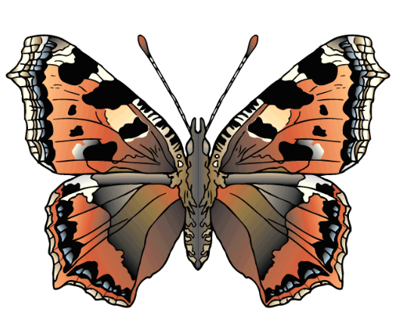
WALT ~ Draw and label the butterfly’s life cycle.
WILF ~ Children who can tell me the different stages in the butterfly’s life. Children who can draw detailed pictures and label the different stages.
Name
19.04.21
Butterfly Life Cycle.

