WALT – double by counting on using a number line wc 15.3.21
WILF I can find the largest number on the number line
I can jump on the correct number of jumps
I can record the answer.
Name

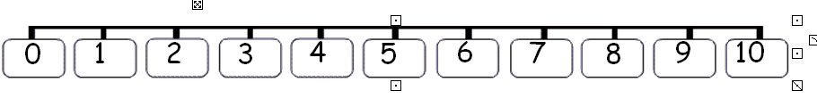
WALT add using a number line wc 19.3.18
WILF I can find the largest number on the number line
I can jump on the correct number of jumps
I can record the answer.
Name

