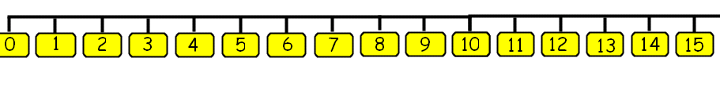


8/3/21 Name
WALT subtract using a number line
WILF I can find the largest number on the number line
I can jump back the correct number of jumps
I can record the number sentence.

