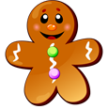
WALT ~ Taking a smaller group of objects away from a larger group.
WILF ~ Children who can count back along a number line and show the number of objects they have taken away and record as a number sentence. Wc 8.03.21

Name

