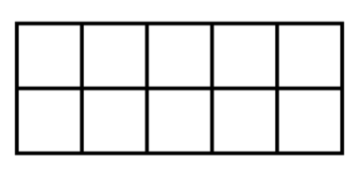
Draw the peas into the ten frame to represent the numeral w/c 22nd Feb
3

5

6
2

Challenge Chest! Solve the equation and draw the correct number of peas on your ten frame.
4 + 3 =

