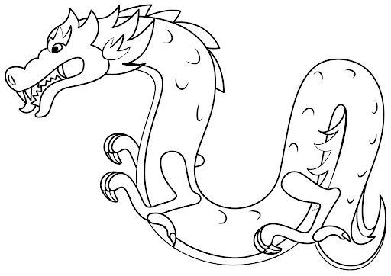
Repeating pattern Chinese New Year dragons w/c 8th Feb

Repeating pattern Chinese New Year dragons w/c 8th Feb

