WALT add by combining two groups wc 22.02.21

WILF I can roll two dice and say what each number is

I can make each number using smarties/raisins/grapes/pennies/glass nuggets.

I can combine both groups to find the total

I can record using the part, part whole model

I can explain my learning.

Name

part

whole

part

 

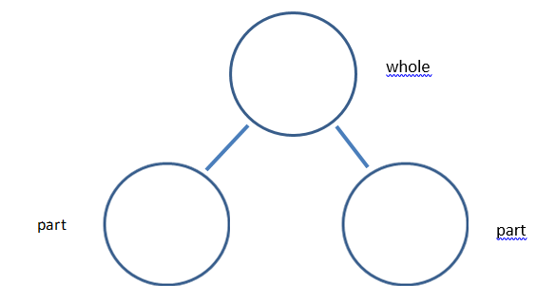

whole

part

part