Date | Week commencing 13.2.17
Learning Objective | Addition by combining two groups, counting on using a number line.
Resources | Flipchart, big pictures, unit 11
Main Activity | Place a balance in the centre of the carpet, ensuring that all pupils can  see the balance. Place 5 blue cubes, 5 yellow cubes and 5 green cubes on  the carpet next to the balance.  Place one green cube on the le: side of the balance and ask pupils to  describe what they no-ce about the balance. [The le: side of the balance  is lower than the right side of the balance.]  Ask pupils to discuss with a partner about what you might need to put on  the right side of the balance to make both sides equal.  Explore how to make the sides of the balance equal by adding different  amounts of yellow or blue cubes to the right side of the balance.  E.g.: Place 5 yellow cubes on the right side of the balance.  Place 1 yellow and 1 blue cube on the right side of the balance.  Through this discussion, pupils should recognise that one green cube is  equal to one blue or one yellow cube.  Repeat with 2 green cubes on the le: side of the balance.  Through this discussion, pupils should recognise that the right side of the  balance will also need 2 cubes to make the balance equal. Explore the  different ways of represent-ng 2 using the yellow and blue cubes, i.e. 2  yellow cubes and zero blue cubes, 1 yellow cube and 1 blue cube and two  blue cubes and zero yellow cubes. | Independent task  Children to choose two number cards. Put the larger number first. Children to create two towers to represent the numbers in different colours. Children to combine both groups and count to find the total. Children to record by writing a part, part whole representation
Greater Depth | Model combining two groups by counting on using a number line.  Children to physically jump along a number line in the classroom  More confident children to draw jumps on their own number line
Maths moments language | Calendar, days of the week.
Continuous provision | Ordering numbers to 20

Name wc 6.2.17
WALT: To use the guess and check strategy for problem solving  Children who can:  Take a guess for a starting point  Adjust their thinking based on their check of the starting point  Use manipulatives to support their thinking  Record using a number sentence |  |  | Place the digit cards 1-5 in the circles only once. The numbers within the 2 circles linked by lines add up to the total to that square.
.
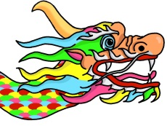
3
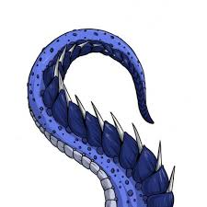
8

6

4

1 | 2 | 3 |  | 4 | 5
1 | 2 | 3 |  | 4 | 5
1 | 2 | 3 |  | 4 | 5
1 | 2 | 3 |  | 4 | 5
1 | 2 | 3 |  | 4 | 5

Name wc 6.2.17
WALT: To use the guess and check strategy for problem solving  Children who can:  Take a guess for a starting point  Adjust their thinking based on their check of the starting point  Use manipulatives to support their thinking  Record using a number sentence | Place the digit cards 1-4 in the circles only once. The numbers within the 2 circles linked by lines add up to the total to that square.
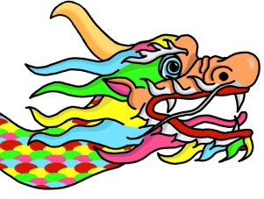
.
5

3

7

