Thursday 4th February 2021
Guided Reading - A Perfect Planet
Watch the clip on YouTube https://www.youtube.com/watch?v=xxibm1ODEpI which is the trailer for David Attenborough’s show “Perfect Planet”.

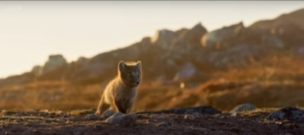
- Choose one word to describe this animal and explain why you chose it:
My word: _________________________________________________
I chose this word because ____________________________________
_________________________________________________________.

- Sir David Attenborough says, “They say perfection doesn’t exist.” Which of these words means something similar to the word perfection?
- Horrible
- Excellence
- Animals
- Hunger

- Which planet does Sir David Attenborough believe to be perfect?
_______________________________________________________.
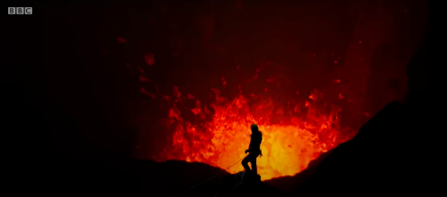
- Would you describe this person as ‘brave’ or ‘bonkers’?
I think this person is ______________ because __________________
_________________________________________________________
_________________________________________________________

- Think about the best weather you have ever experienced. How did you feel?
I felt ____________________ because _____________________________________________
____________________________________________________________________________.

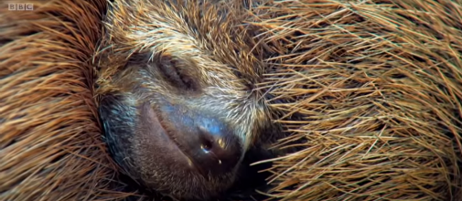
- How do you think this animal is feeling?
I think this animal feels _____________________ because it _______
_________________________________________________________
________________________________________________________.

- Which animal from all those featured in the trailer do you like the most?
The animal I like most is the _____________________ because __________________________________
______________________________________________________________________________________.

- Has this trailer made you want to watch the TV show A Perfect Planet? Why?
This trailer has/has not made me want to watch A Perfect Planet because __________________________
________________________________________________________________________________________

