Wednesday 3rd February 2021
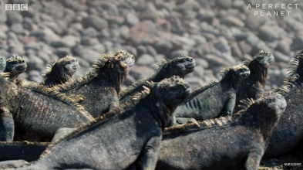
Guided Reading - The Marine Iguana
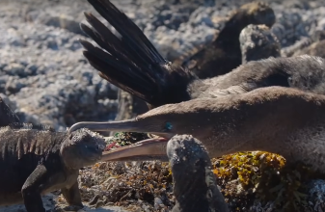

Watch the clip on YouTube: https://www.youtube.com/watch?v=UDAutlF_aRY titled The Marine Iguana, taken from David Attenborough’s show “Perfect Planet”.
- Marina Iguanas are vegetarian.
True / False

- Why do the birds bring seaweed ashore? Tick one.
- To tidy up.
- To eat.
- To make nests.
- To annoy fish.

- Pause at 48 seconds. How do you think the Marine Iguana feels here?

- Can you think of three adjectives to describe the bird’s beak?
- ____________________________________________
- ____________________________________________
- ____________________________________________

- Which of the following is the correct definition for the word ‘neighbour’? Tick one.
- Someone/thing who lives next to or very near to someone/thing else.
- Someone/thing who lives far away from someone/thing else.
- Someone/thing who likes to neigh like a horse.
- Someone/thing who is always fighting with someone/thing else.

- The marine iguana is the only lizard in the word to get its food from where?

- How long can the marine iguana spend in the water?

The marine iguana can spend _____________________________ in the water.

- Complete the table to show whether each statement is true or false.
 | True | False
The animal featured in this clip is a type of snake.
Birds bring seaweed onto the island.
Thousands of marine iguana live on the island.
The marine iguanas are carnivores.

