Monday 1st February 2021
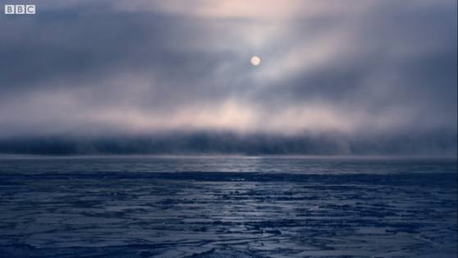
Guided Reading – Return of the Emperor
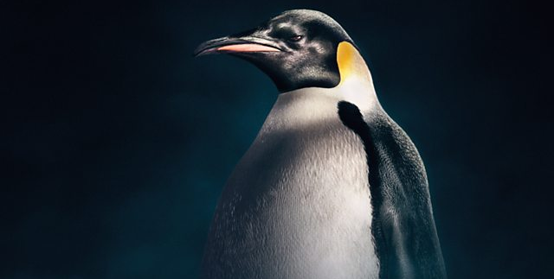

Watch the clip titled Return of the Emperor, taken from the second episode of David Attenborough’s Dynasties which focuses on the Emperor Penguin…
https://www.bbc.co.uk/programmes/p06rj12s

- Where in the world do you think this is? Explain your answer.
- What animal arrives in the new world’?
- How many Emperor Penguins are coming to the frozen bay?
- Why do you think thousands of Emperor Penguins would want to go somewhere so cold and empty?
- What does the new ice provide?
- Choose 3 adjectives to describe the setting in the clip.
- How long will the ice last?
- What will happen to the ice next summer?
- What does the word ‘raise’ mean in the sentence, ‘they will need every day of those nine months to raise the next generation of this great Emperor dynasty’?
- Which word do you think best describes the setting in this clip?
- Cold
- White
- Frozen
- Sunny
- Busy

