How do clouds make rain?
The EYFS science experiment: Cloud in a Jar
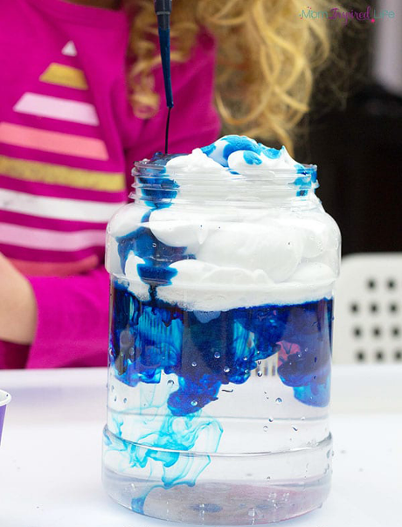
What you need:
- A jar of water
- Blue food colouring
- Shaving foam
- A medicine dropper or pipette

How you do it:
Using a glass of water to demonstrate the “sky”, create a cloud to hover at the top by using shaving foam.

Now, use a medicine dropper or a pipette to drop little droplets of food colouring into the cloud.

Eventually, the food colouring will seep through the cloud to demonstrate rain.

Children may start to grasp the relationship to our outside world, how this is what happens when clouds get too heavy – some of the water has to rain down.

