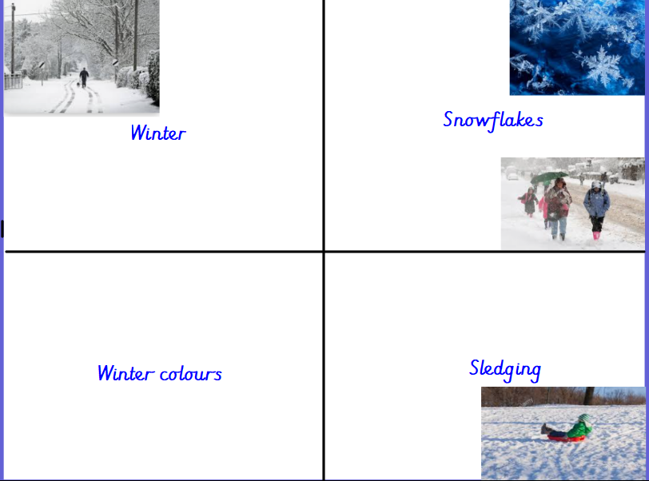
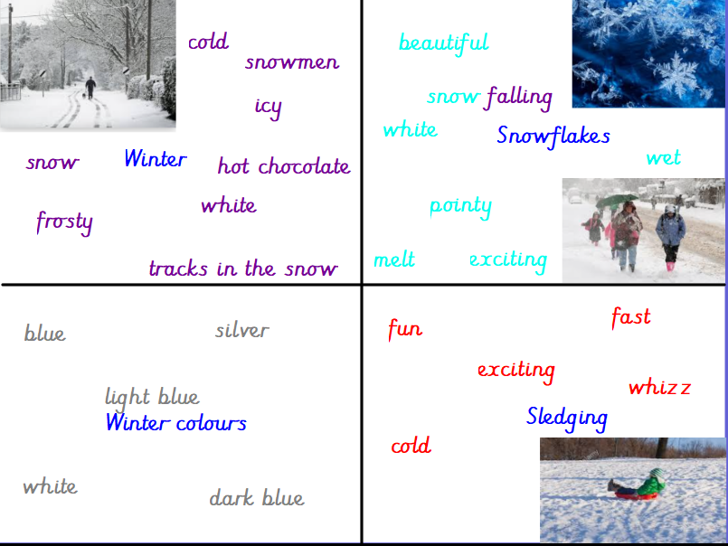

Winter
Winter is tracks in the snow
Winter is cold mornings
Winter is making snowmen
Winter is drinking hot chocolate

Snowflakes, snowflakes
White and silver

Winter is sledging
Winter is fast
Winter is exciting
Winter is whizz

Snowflakes, snowflakes
White and silver

