If you are looking for additional ways to support your child’s literacy learning, please have a look at these free interactive games which we often play in class. The children love to learn using the class iPads, or by playing the games on our interactive whiteboard in the classroom, so we are sure that they will have great fun practising some of our key skills at home too!
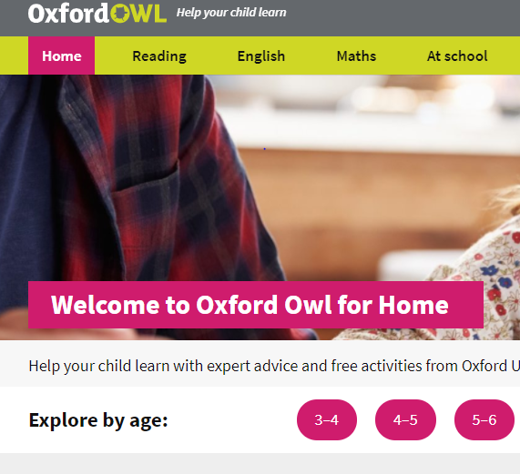
www.oxfordowl.co.uk
Please click on the 3-4 tab on ‘Explore by age’ to find lots of tips, tricks and games to play with your child.

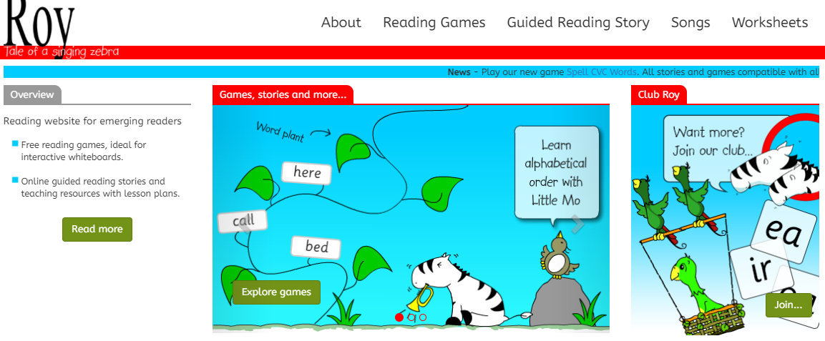
www.roythezebra.com
Click on tabs at the top of the page to find lots of different activities, games, stories and songs to explore together. Happy reading!

https://www.phonicsplay.co.uk/resources/phase/1
Click on ‘Resources’ tab, then ‘Phase 1’ to play games for early readers. There are also some initial sound games in the ‘Phase 2’ tab which you could look at too.

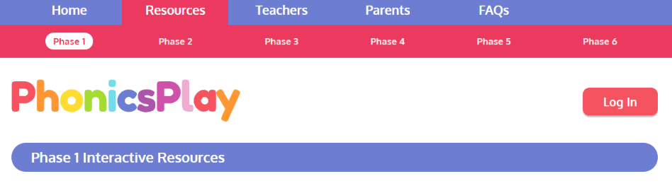

There are also other ideas and activities for you to enjoy on the following websites too;

- Ruth Miskin Read, Write, Inc. www.ruthmiskin.com
- www.topmarks.co.uk
- www.crickweb.co.uk

