Lost and found challenges
We are starting our winter topic, so the challenges for this week are a wintery theme. There is no expectation to complete all of these challenges, just some ideas to keep busy. Please send pictures for us to share on the website or twitter.
Cosmic yoga- find a space and settle down to do a winter yoga session. https://www.youtube.com/watch?v=DP9jd1Ug2y4 | 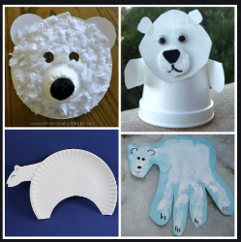  Make a polar bear face using a paper plate (or circular piece of paper), cotton wool, glue and coloured pens. | Watch Oliver Jeffers (author of lost and found) tell a story whilst illustrating.  https://www.bbc.co.uk/events/eb4bj5/play/a2pnc8/p00tvfjj | Play a game.  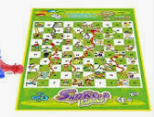  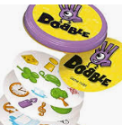
Pretend to be a penguin, can you walk like a penguin? Slide/roll on your tummy like a penguin. Listen to the music ‘March of the penguins’ and be a penguin.  https://www.youtube.com/watch?v=jl6Ey1mrJPY | Learn how to draw a penguin. Find 3 different size circles to draw round and follow the instructions below. 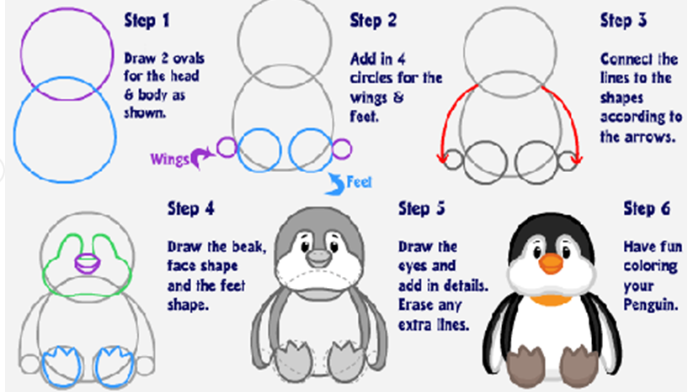 | 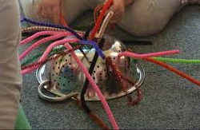  Funky fingers- how many pieces of spaghetti or pipe cleaners can you thread through a colander? | Ask a family member to read or tell you a story over the telephone, facetime or Zoom. Or listen to a story on purple mash.
Draw or print out some penguins, can you write numbers 1-6 on their tummies. Then mix them up and put them in the correct order  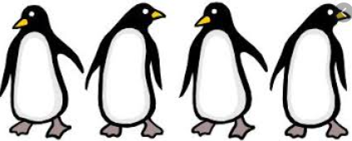 | Go for a walk, take a picture.  What can you hear, see, touch, smell?  Draw a picture when you get home. If you want to tell your adult each aspect from the fan they will label it for you.  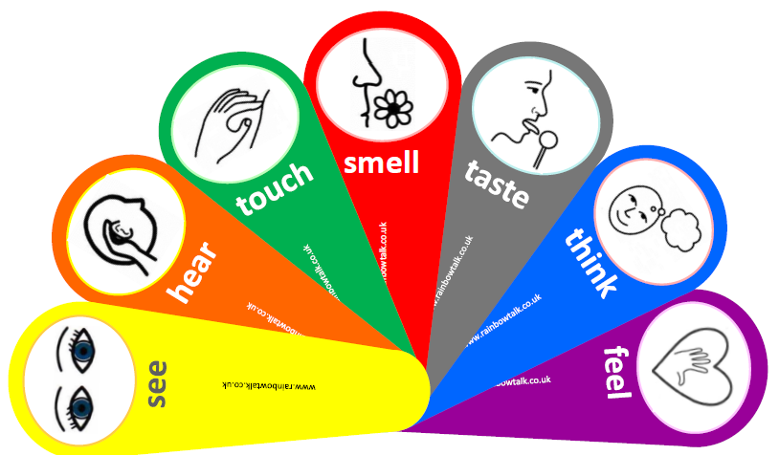 | 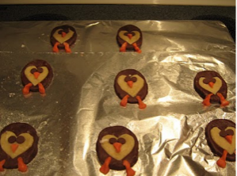  Make food that looks like a penguin. | Make a penguin  