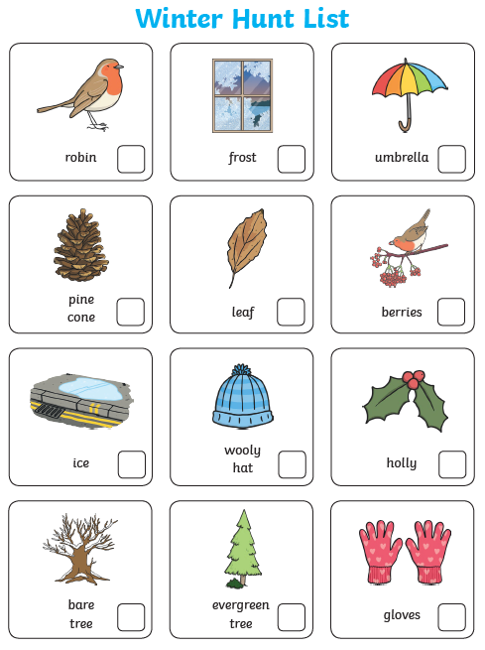

When you are out and about in your garden or on a walk in your local area, can you see if you can spot any of these signs of winter? Tick them off if you see them.