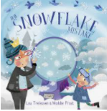
Design your own snowflake machine
This was the Queen’s snowflake machine, design your own machine. What shape will it be? Will it have tubes, funnels?

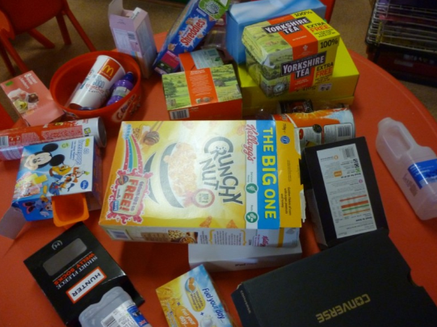
Now make your machine using junk modelling resources:

