Snowflake mistake by Lou Treleaven & Maddie Frost
Parental note: Children can mark make or draw pictures in these boxes to respond. If you’d like to annotate below to share with us, that’s great! Thank you
When the snowflake machine breaks, what happens?
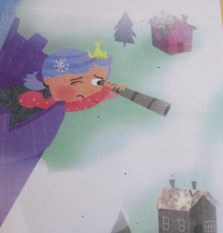

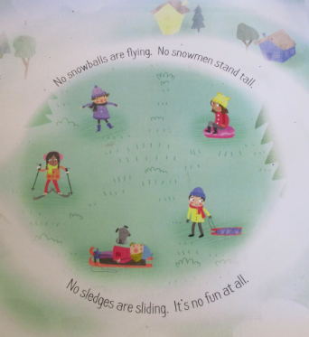
How do the children feel?

