|  |  |  |  |  |  |  |  |
| --- | --- | --- | --- | --- | --- | --- | --- |
| **Monday** |  | Learning through play |  |  |  |  |  |
| **Tuesday** |  | Learning through play |  |  |  |  |  |
| **Wednesday** |  | Learning through play |  |  |  |  |  |
| **Thursday** |  | Learning through play |  |  |  |  |  |
| **Friday** |  |  |  |  |  |  |  |

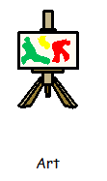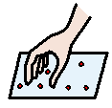

Learning through play