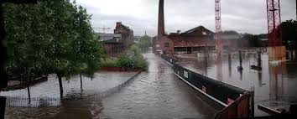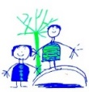DIS Year 2

**Under the Sea – Spring**

**Literacy:**

Finding Nemo adventure story

Fact file about an underwater animal

Learning about apostrophes for omission and possession.

Past and present tense verbs

Plurals

**History:**

Sheffield Floods of 1864 compared to Sheffield Floods in 2007.

The effects and consequences.

**Other Curriculum Areas:**

**PE:** dance skills

**PSHE:** Focus is on families. Are all families the same?

**DT:** Create an underwater scene to develop knowledge of lever and sliders

**Art**: Become confident in using water colours and create an underwater picture.

**RE:** Buddhism – story, symbols, comparison between other religions

**Music**: Charanga – beat and pitch

**Metacognition**: develop further Growth Mind Set skills.

**Geography:**

We will be learning about the 5 Oceans.

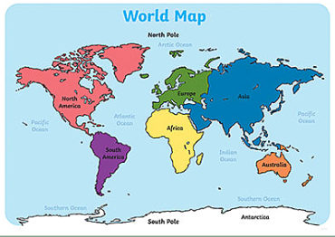

**Star Words:**

oceans, Atlantic, Artic, Pacific, Indian, Southern, equator. Recap Compass points

**Key Knowledge:**

Name and Locate the 5 Oceans

**Science:**

Identify different habitats and Micro habitats in Oceans. Describe how different habitats provide for the basic needs of animals and plants.

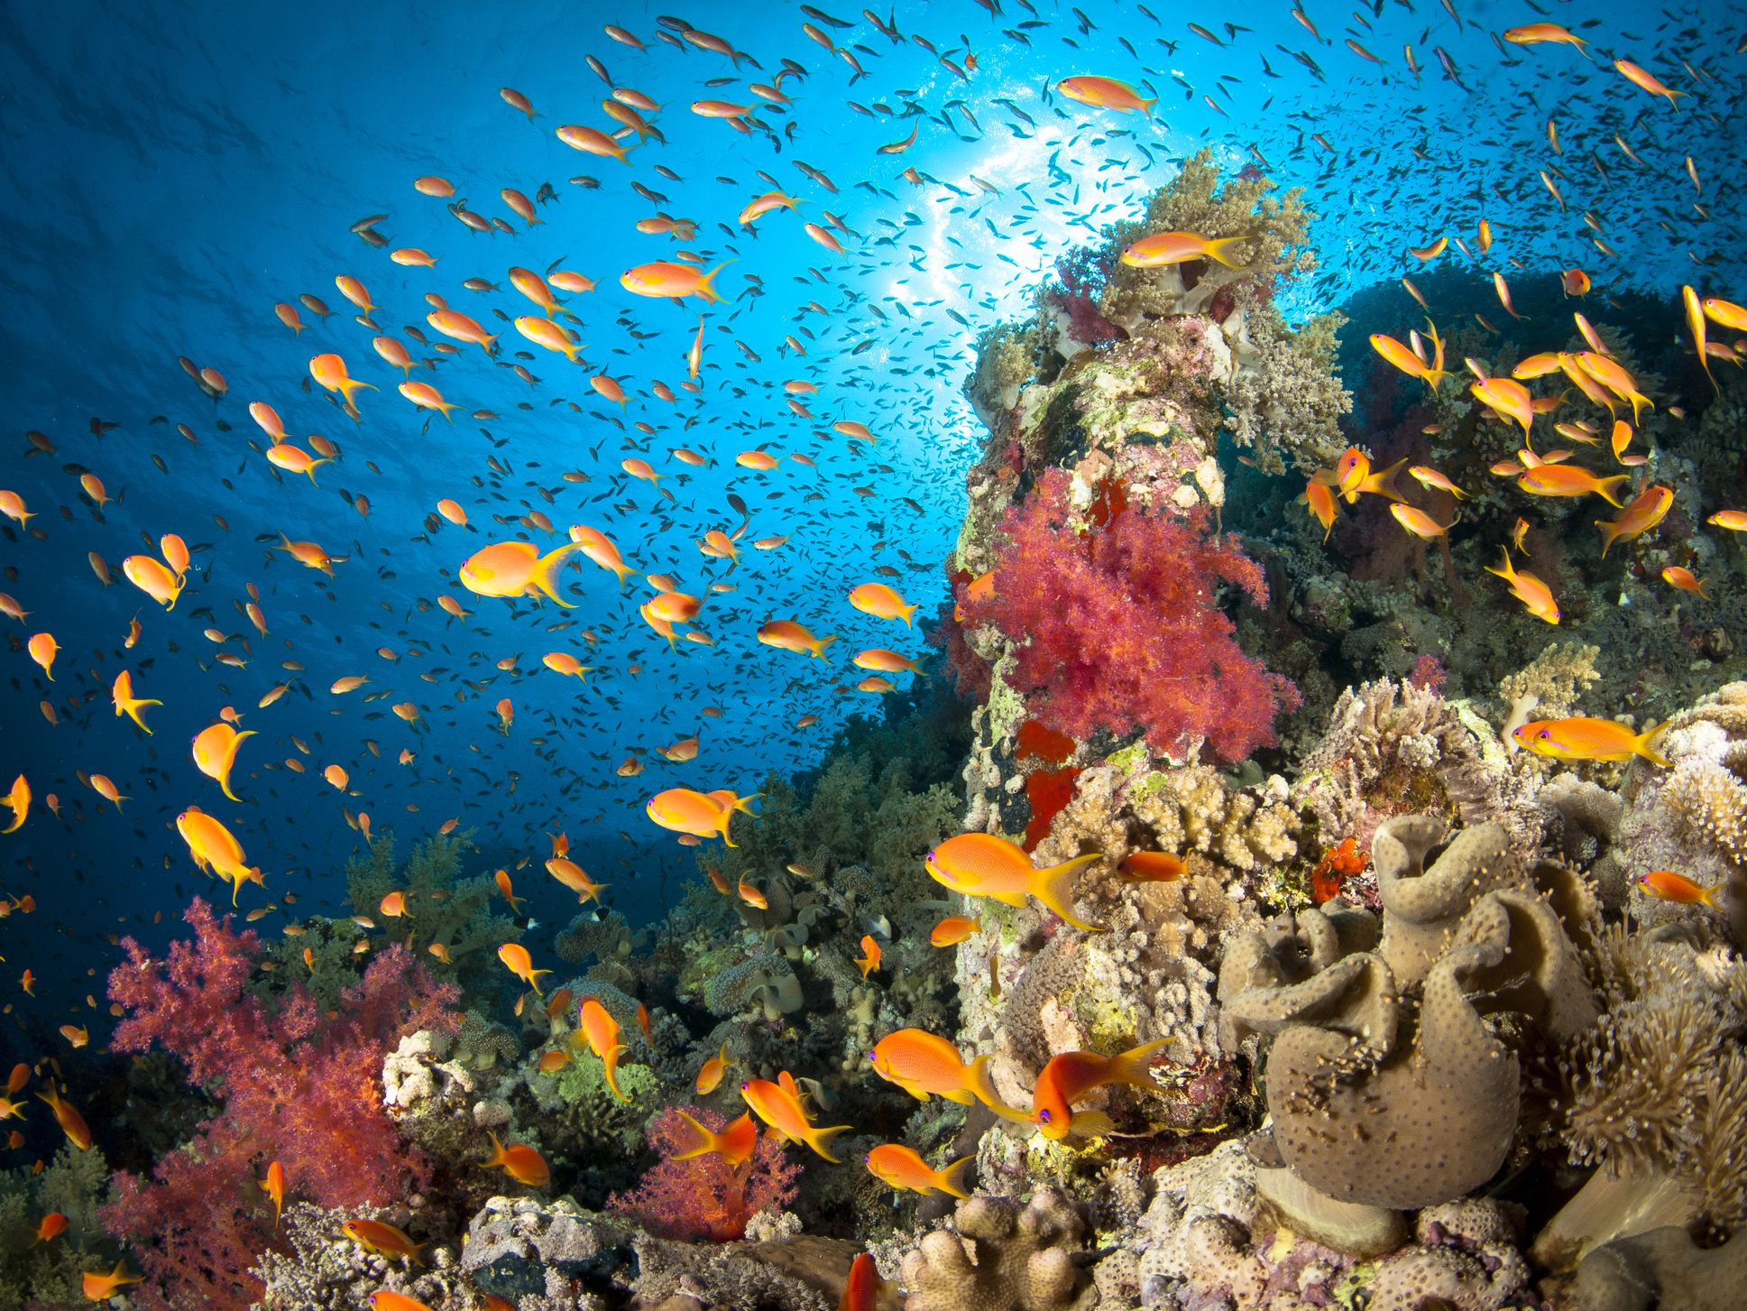

**Star Words:**

Habitat, micro habitat, oceans, predictors, consumer,

**Key Knowledge:**

Identify that most living things live in habitats to which they are suited.