Welcome to the spelling zone
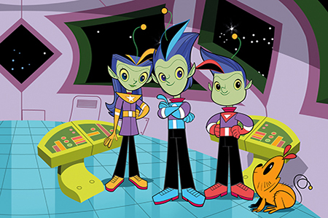
Join Alpha, Gamma and Zeta on the journey to becoming star spellers!
Remember – Practise makes perfect
Year 2 common exception words

Mercury | Venus | Earth | Mars | Jupiter | Saturn | Uranus | Neptune
after | kind | move | old | chased | break | great | sugar
would | mind | prove | told | child | steak | pretty | water
could | find | improve | cold | children | money | whole | grass
should | behind | door | gold | Mr | half | who | clothes
again | beautiful | floor | hold | Mrs | more | only | climb
because | any | poor | every | father | hour | wild | Christmas
people | many | there | everybody | parents | even | both | eye
used | they | most | which | busy | first | with | sure

