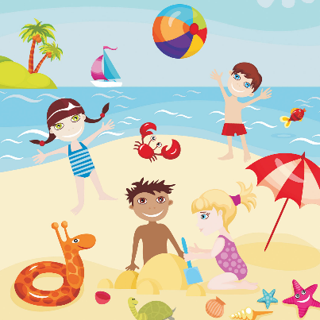
Summer Term 2: Week 7
English Task 2

Take a look at your robot invention from yesterday.

Our robots are going on their summer holiday!
What do you think they would find interesting / strange / funny about the seaside?

Write a short creative story about your robot’s trip to the seaside!
Think about:
- What activities do they try (sandcastles, fairground, swimming, ice cream)?
- What does he find strange / funny?
- Does he make a friend?
- Does something bad happen?
Be as creative as you can!

