WALT : Design and make a board game. 4.7.19

Can you design and then make your own board game to play at home ? Do your research by playing some of the different board games you already have. Your game could be a race around a track or involve matching up pairs. It could have a theme like seaside or pokemon. You need to decide what the rules are and how someone will win. Have fun !
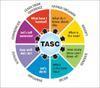
Even Better If :
What Went Well :
My design :

Evaluation :

