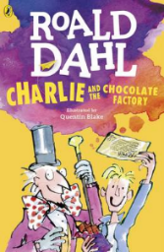
Charlie and the Chocolate Factory
Read Chapter 16 of the book or listen to it using this link https://www.youtube.com/watch?v=qCuNSZjCKg8

1) Listen to the story.
2) Discuss key questions.
3) Use the text to find evidence and answer the questions.

- Why is Loompaland ‘a terrible place’? Give 2 reasons. (page 83-84)

2. Name 2 things an Oompa Loompa likes. (page 86)

- Who had quietly sneaked down to the edge of the river? (page 86)

Mike Teavee Mrs Salt

Augustus Gloop Charlie Bucket

