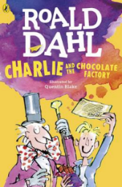
Charlie and the Chocolate Factory
Read Chapter 15 of the book or listen to it using this link https://www.youtube.com/watch?v=qCuNSZjCKg8

1) Listen to the story.
2) Discuss key questions.
3) Use the text to find evidence and answer the questions.

- Why were the children and their families “too flabbergasted to speak”? (page 79)

- Find and copy a question the visitors ask about the Oompa Loompas. (page 82)

- Number the events from the chapter in order from 1-4. One is done for you.
The visitors see the Oompa-Loompas
Everyone bent down and ate some of the grass
1
Mr Wonka slipped a key into the keyhole of the door
Veruca Salt screamed

