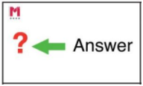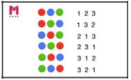

Write this repeated addition equation as a multiplication equation, then find the answer.

***Example:* 3 + 3 + 3 + 4 + 4 = 3 x 3 + 4 x 2 = 9 + 8 = 17**

4 + 4 + 4 + 3 + 3 + 3 + 3 =

Look at the first 6 equations for the 2x and 4x tables. What pattern do you spot? Can you think of any other times tables that might follow this pattern?

1 x 2 = 2 1 x 4 = 4

2 x 2 = 4 2 x 4 = 8

3 x 2 = 6 3 x 4 = 12

4 x 2 = 8 4 x 4 = 16

5 x 2 = 10 5 x 4 = 20

Sam buys 3 packets of biscuits and there are 6 biscuits in each packet. Sarah buys 4 packets of biscuits and there are 5 in each packet.

Who has bought more biscuits?

Show your working.



**True or False?**

3 x 10 = 13

5 x 4 = 20

3 x 8 = 28

7 x 4 = 11