WALT draw self-portraits. w/c 6.7.2020
I can use my pencil to sketch my portrait.
I can think carefully about how to draw my features.
I can self-assess my first portrait and improve it.

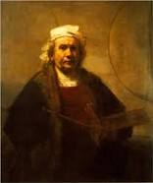
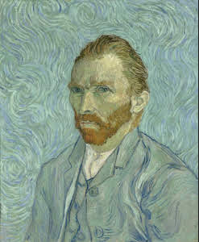
A self-portrait is when an artist draws a picture of themselves. Here are some self-portraits by famous artists.
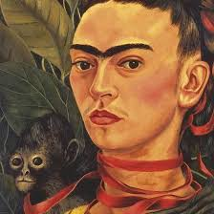
Frida Kahlo Vincent Van Gogh Rembrandt
We are going to create super hero self-portraits! They will look like this:
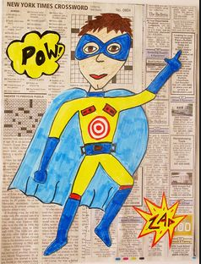
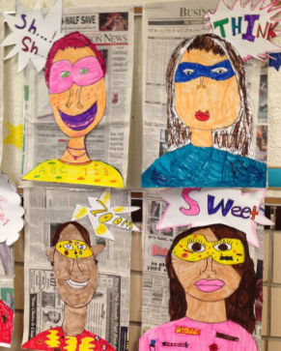
First you need to practise drawing a self-portrait of yourself. You need to decide whether to draw your whole body or just your head and shoulders. When you are happy with your self-portrait, cut it out and stick it onto a newspaper background. Colour it in with bright, bold colours.
Finally, you need to make some onomatopoeias to stick around the edges. An onomatopoeia is a word that sounds like what it describes. Here are some examples.

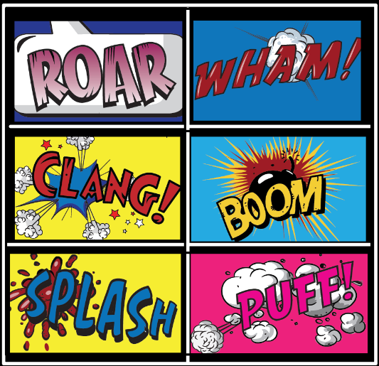

We can’t wait to see your super hero portraits!

